# 一、设计思路

在本次作业中，一共设计了5个页面，包括

* “About”——【index.html】
* “经验”——【skill.html】
* “个人Blog”——【blog.html】
* “生活碎碎念”——【life.html】
* “分享”——【share.html】

5个页面分门别类展示我的个人信息、技能、博客、联系方式以及日常生活记录等等。在设计网站的过程中，首先创建测试文件，搭建所有页面的基本布局与结构，然后具体到各个页面，做出相应的内容与布局调整。

**项目文件结构如下所示：**

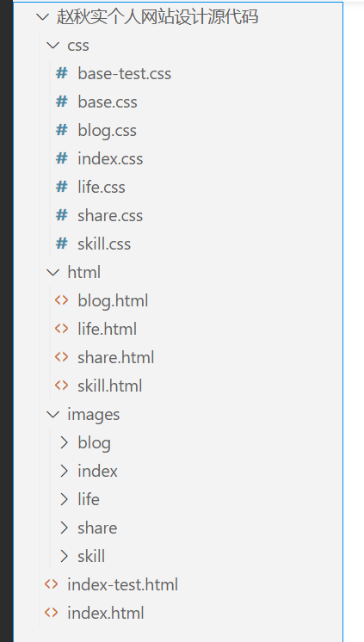

按照文件类型将css、html和图片文件分别收纳到不同文件夹中。

css文件夹包括7个文件，base-test.css属于布局测试文件，其余6个css文件中，base.css定义各个网页的基本样式，其他5个css文件对应5个页面，定义各个网页样式的不同之处。

html文件夹包括非首页的4个页面，在文件夹之外的index.html是首页文件，index-test.html属于测试文件。

images文件夹存放不同页面所需的图片文件。

# 二、框架结构

## 1. 内容

### 页面1：About【index.html】

主要介绍基本个人信息，包括简历卡片、项目经历、座右铭、生活照片和个人能力简介，成果图如下：

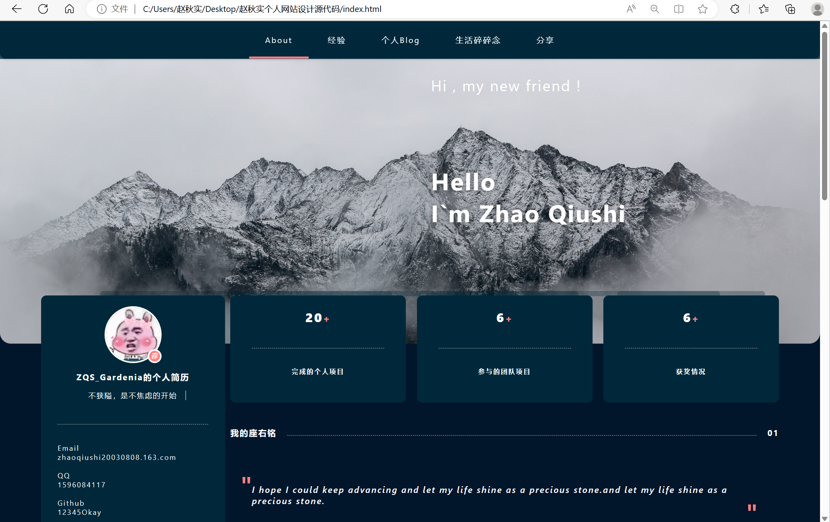

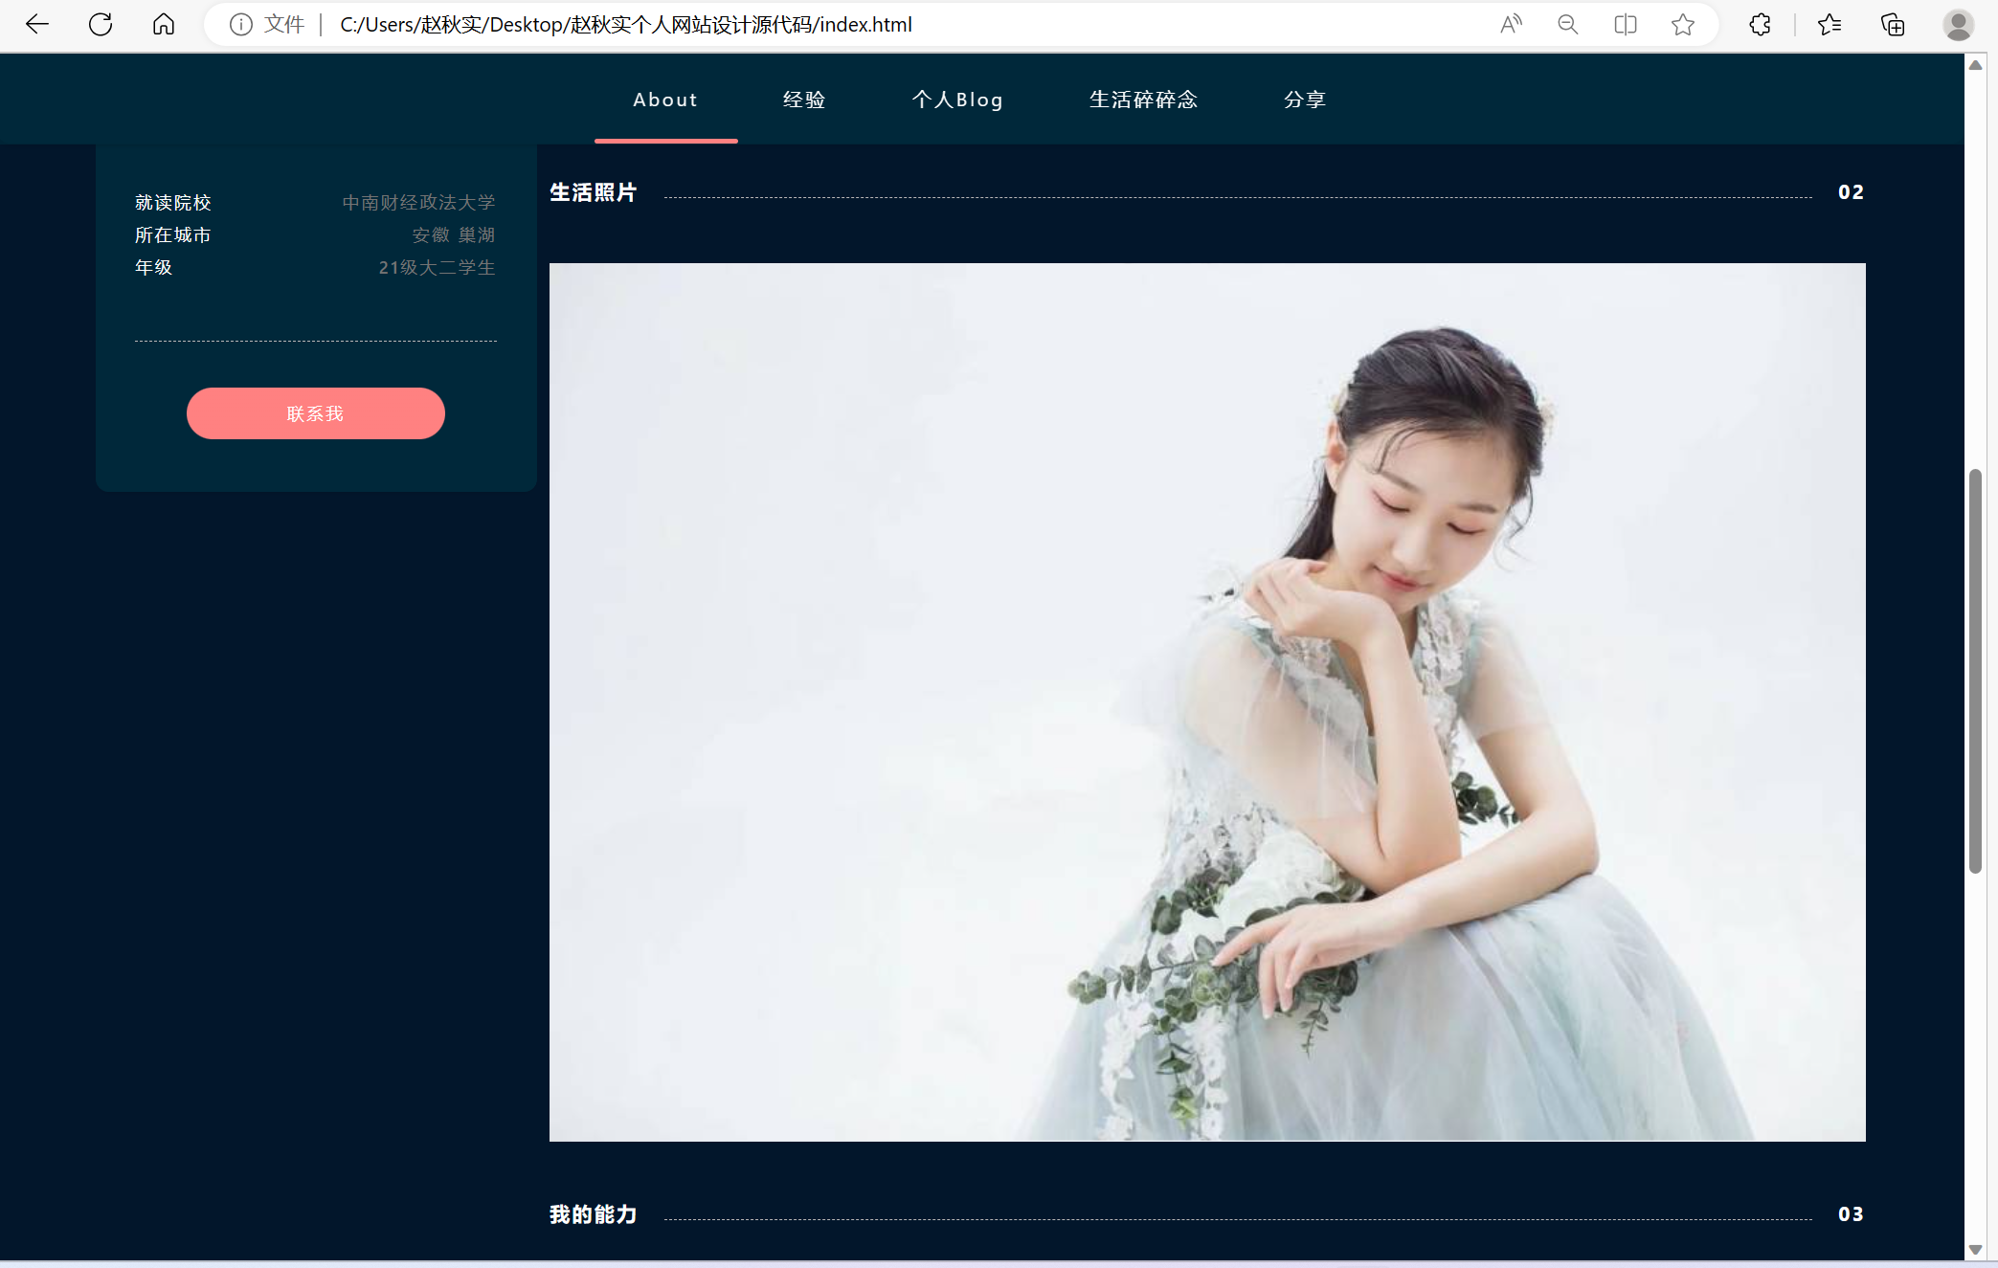

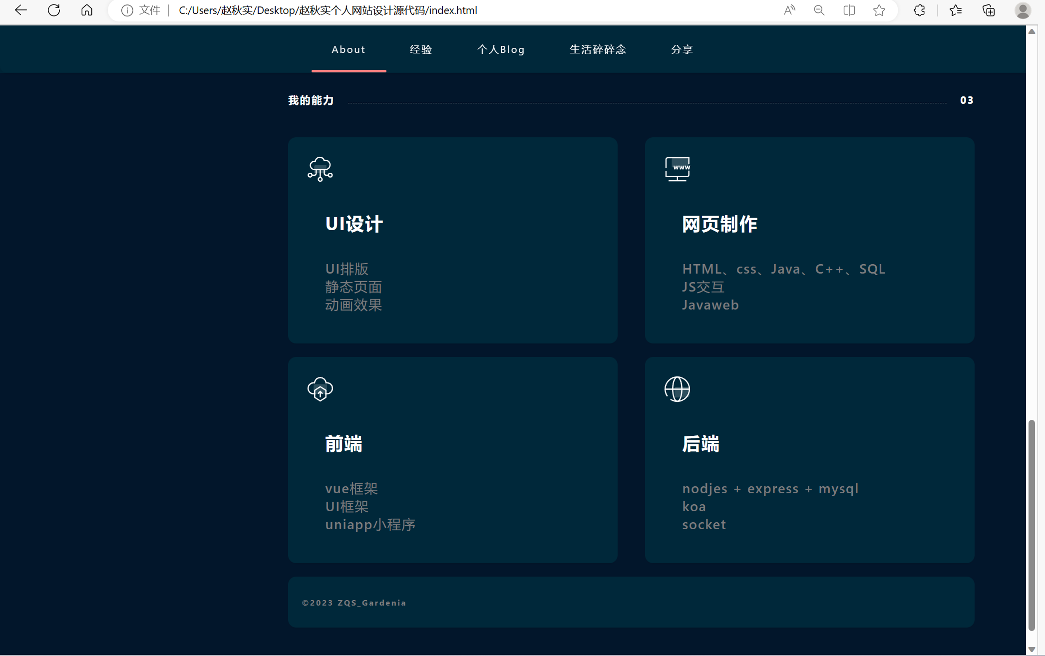

打开页面，“不狭隘，是不焦虑的开始” 这句话会有逐渐左移的动画效果：

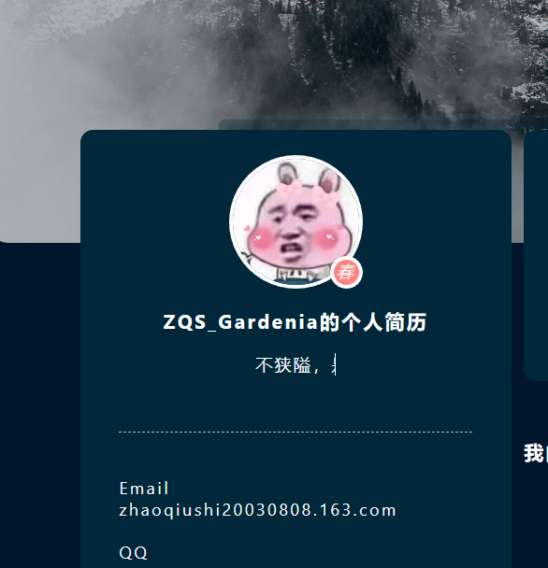

昵称“春华秋实”的动画效果如下所示：

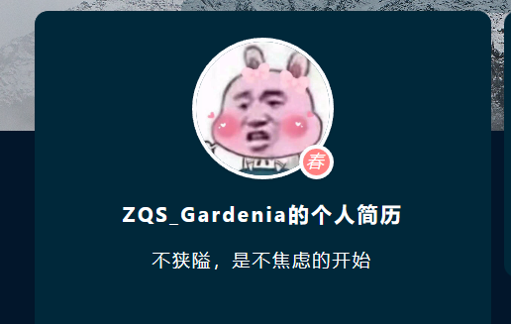 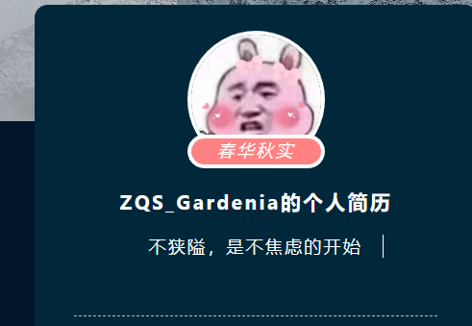

点击个人卡片中的“联系我”，可以向我发送邮件：

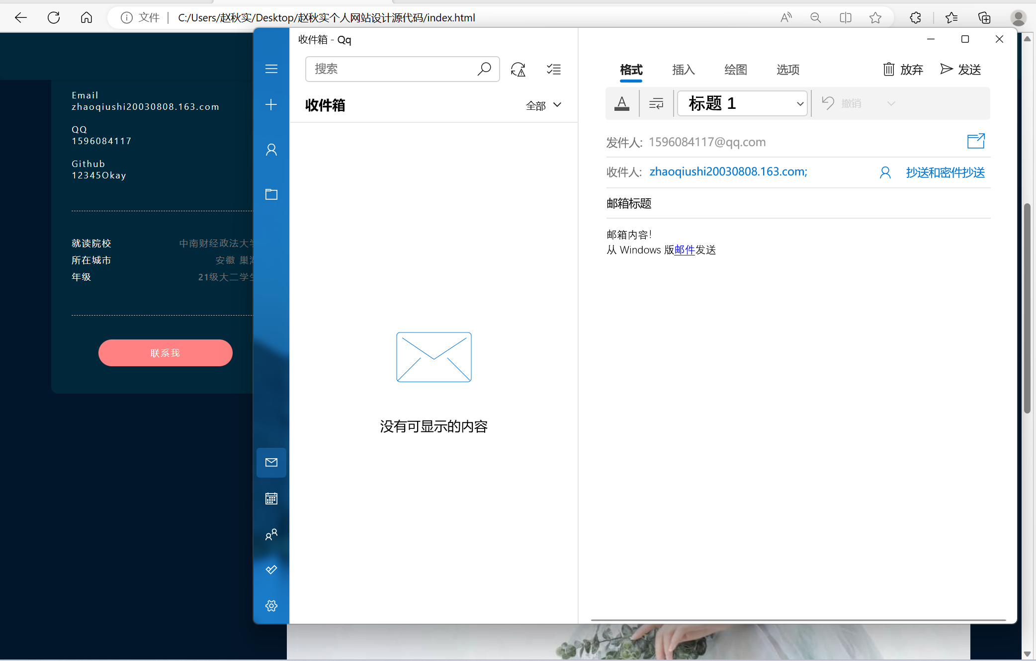

### 页面2：经验【skill.html】

详细介绍我所掌握的各项技能和个人学习经历，成果图如下：

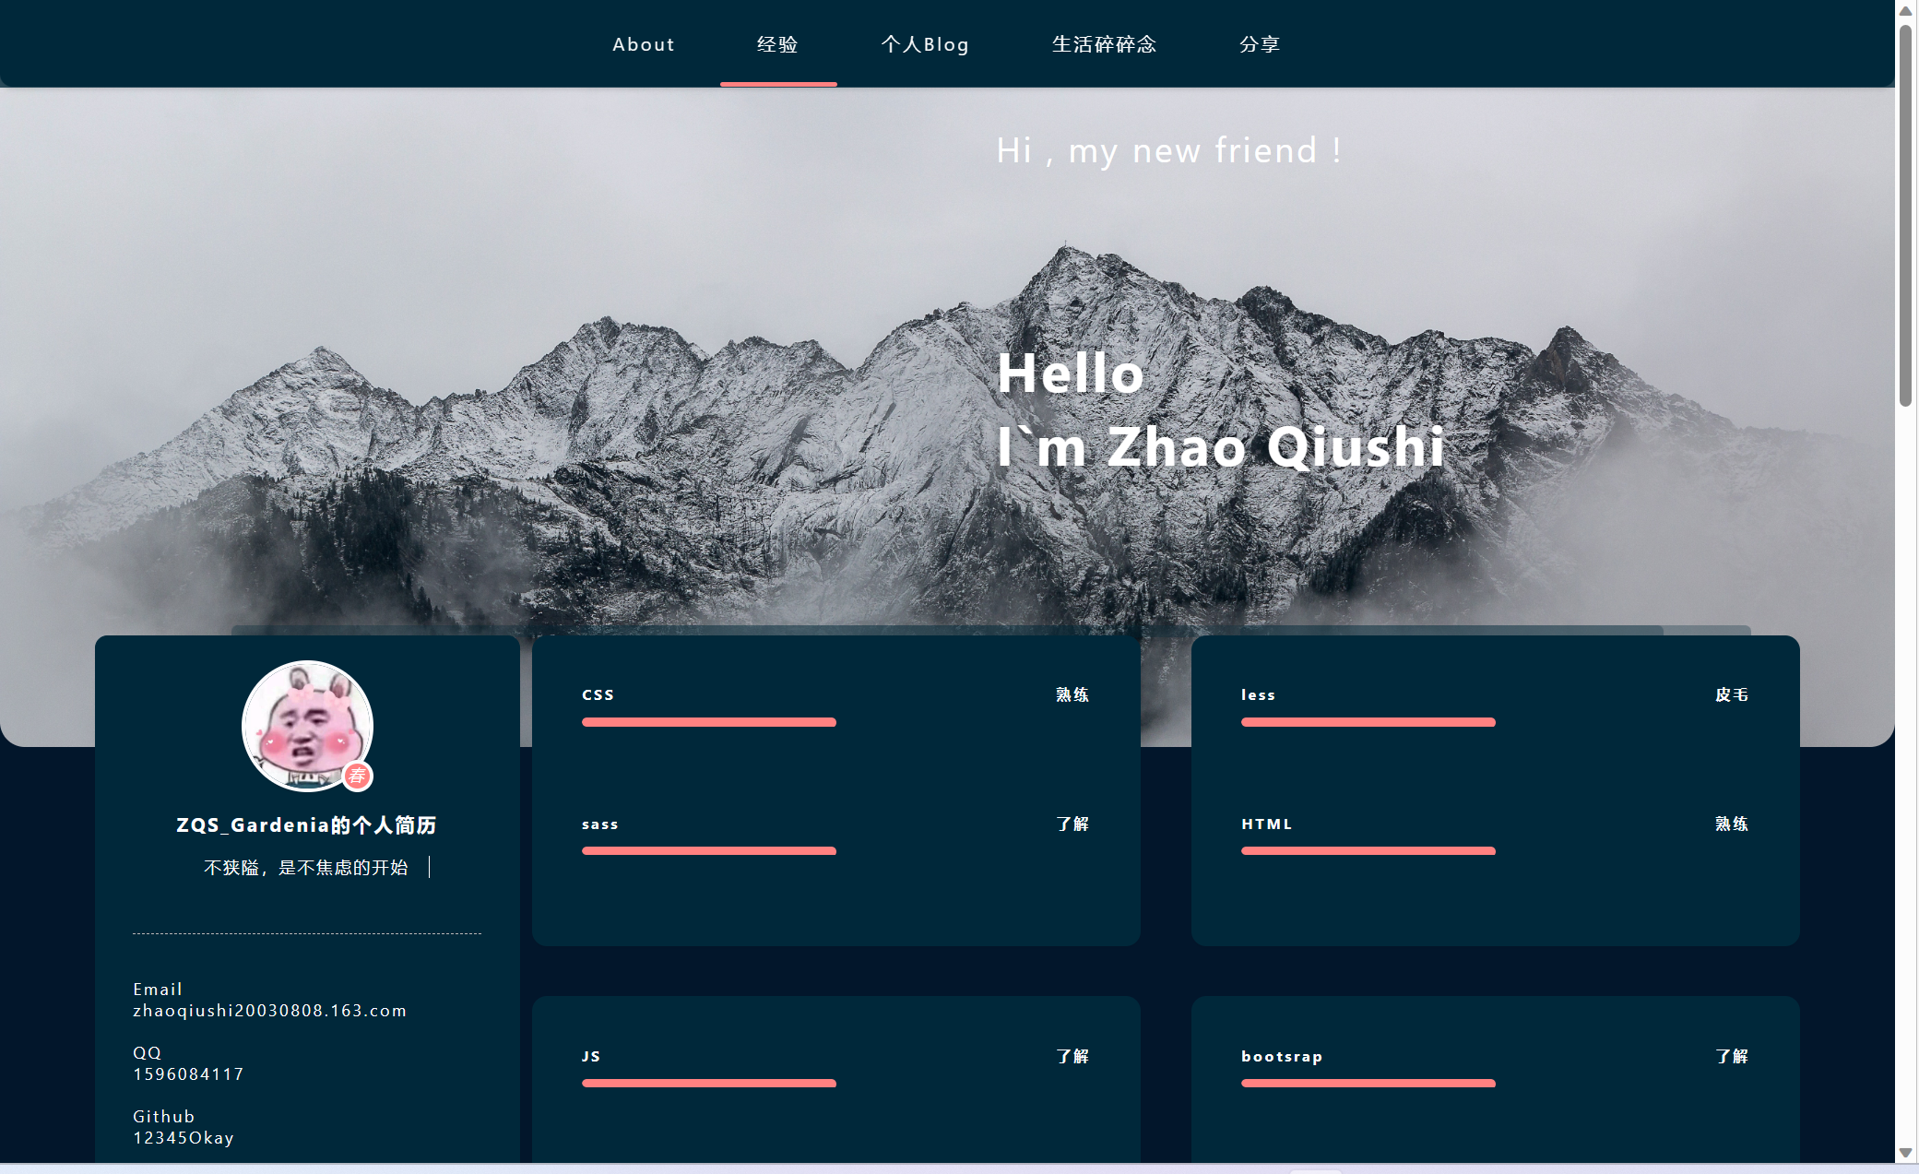

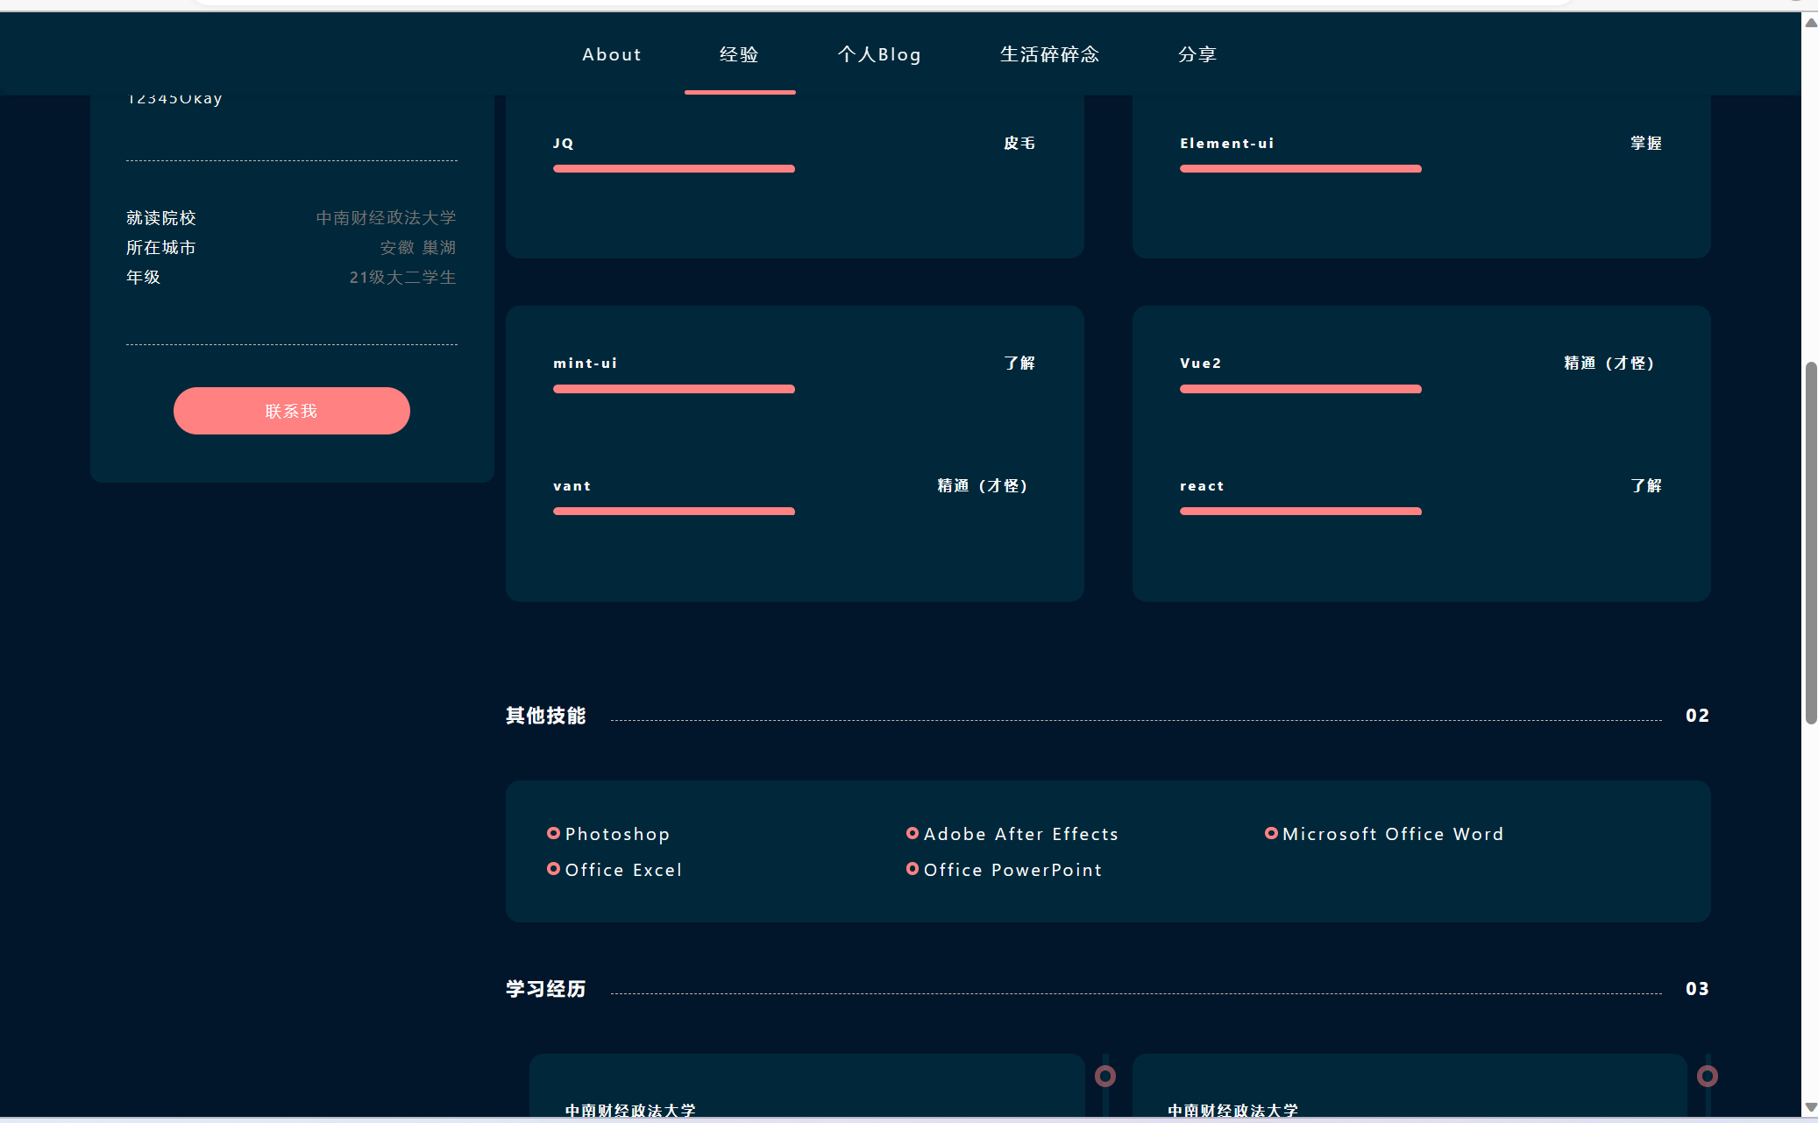

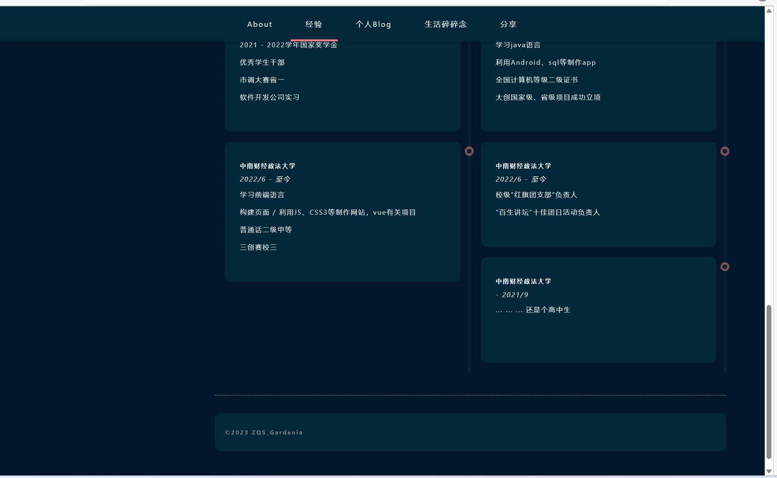

鼠标移动到上面的若干红色圈圈上，会有灯光亮起的视觉效果：

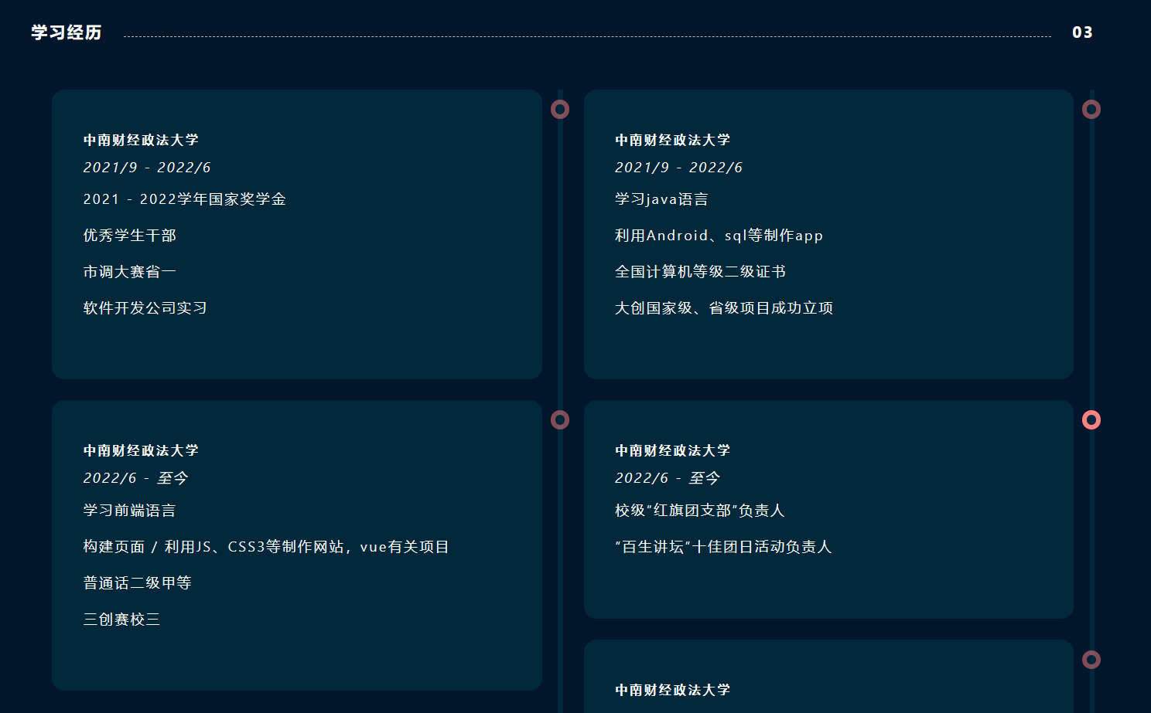

### 页面3：个人Blog【blog.html】

展示部分Blog和文章，成果图如下所示：

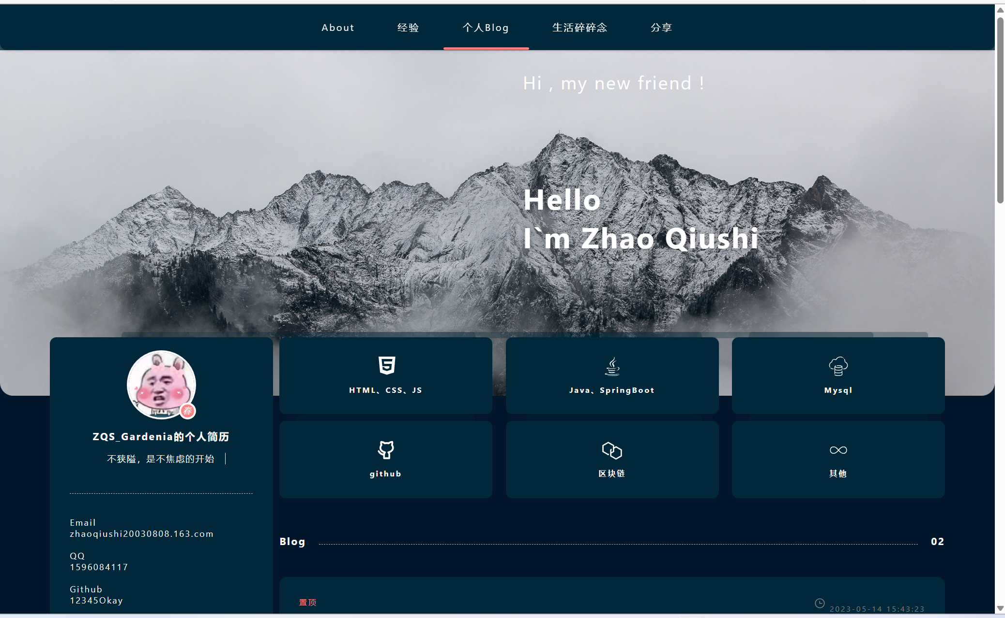

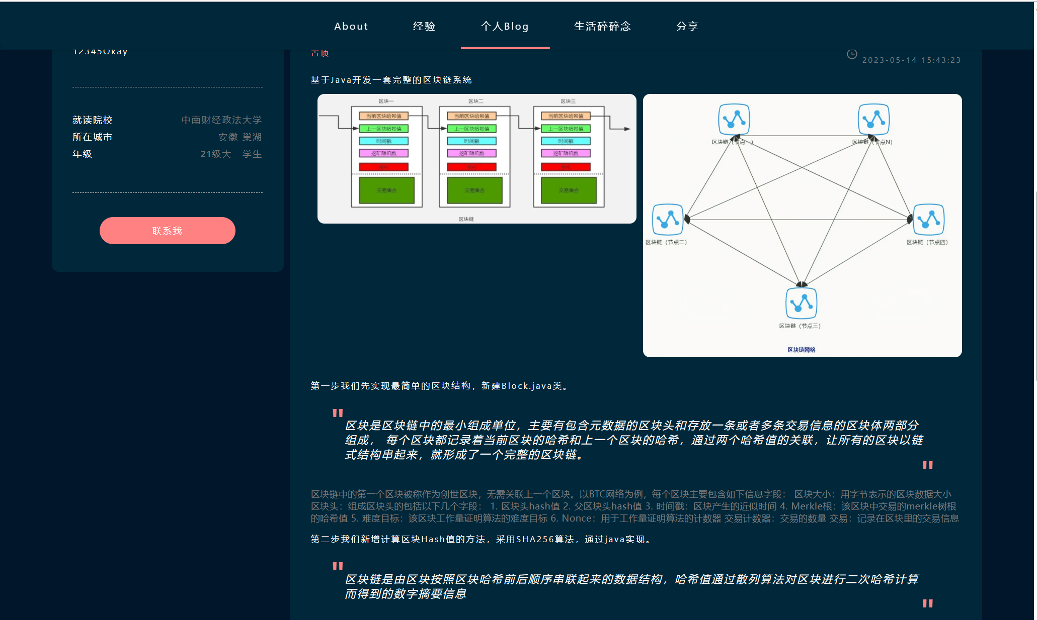

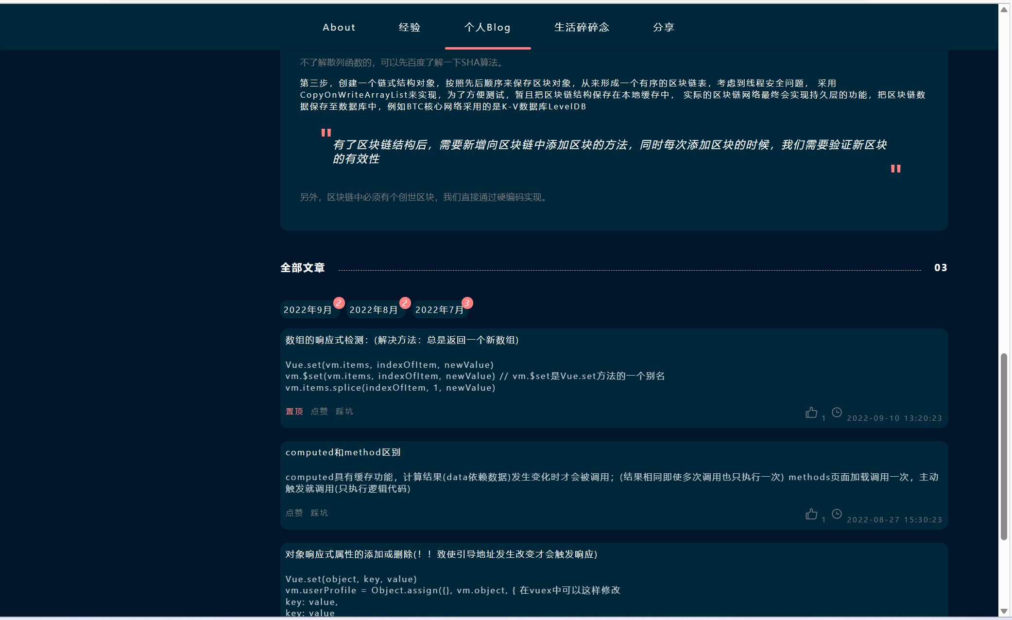

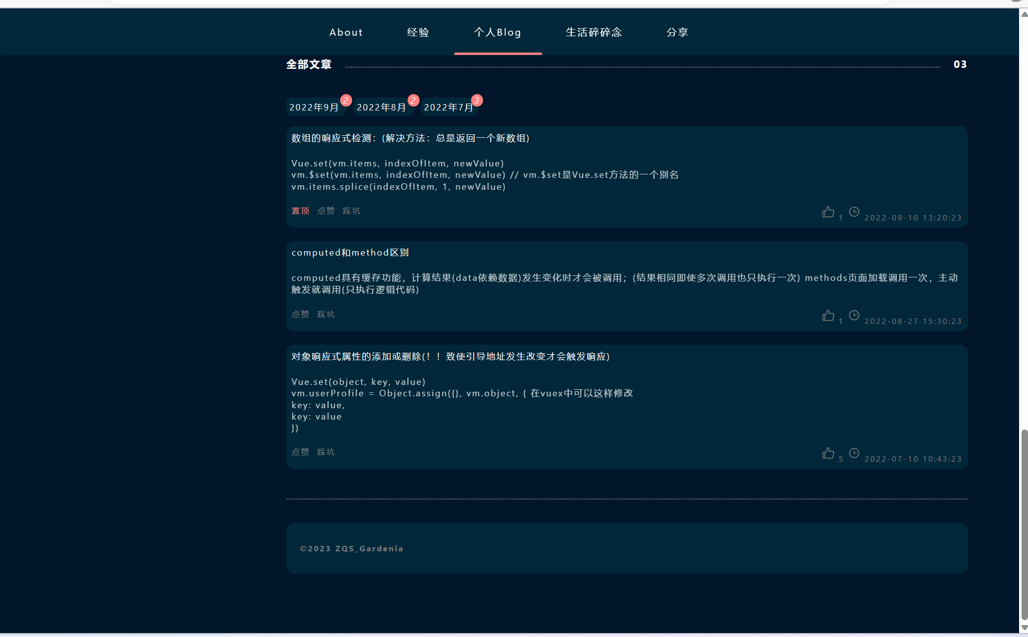

### 页面4：生活碎碎念【life.html】

这一部分主要记录日常生活中遇到的精彩瞬间，成果图如下：

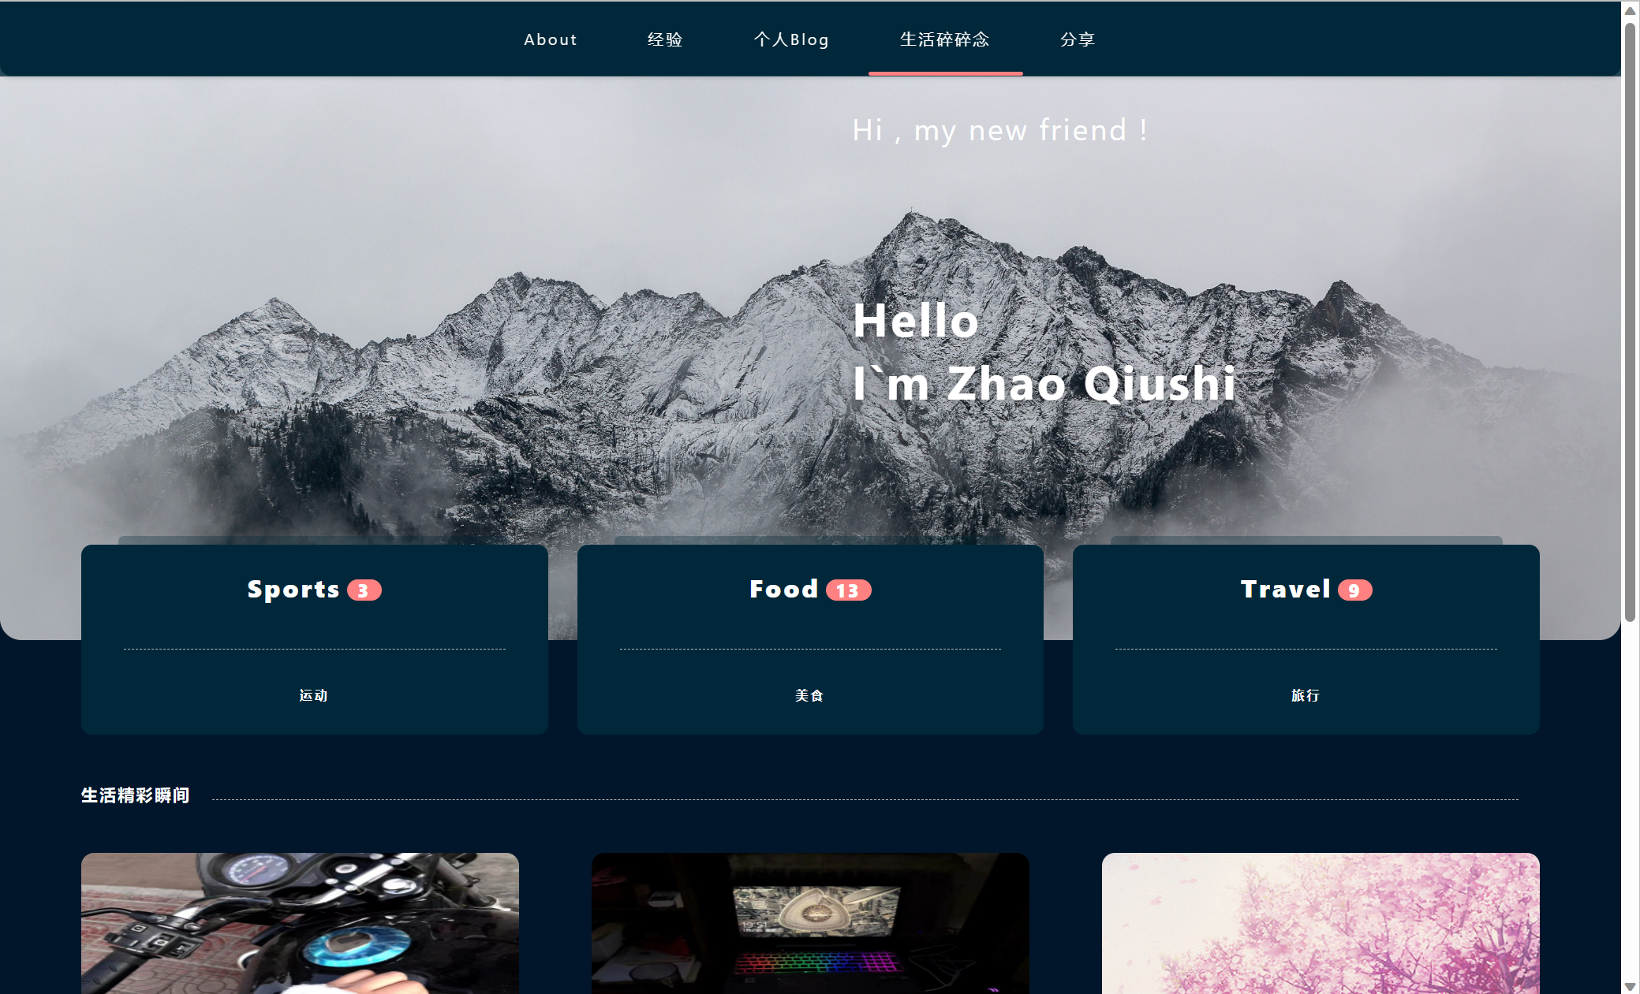

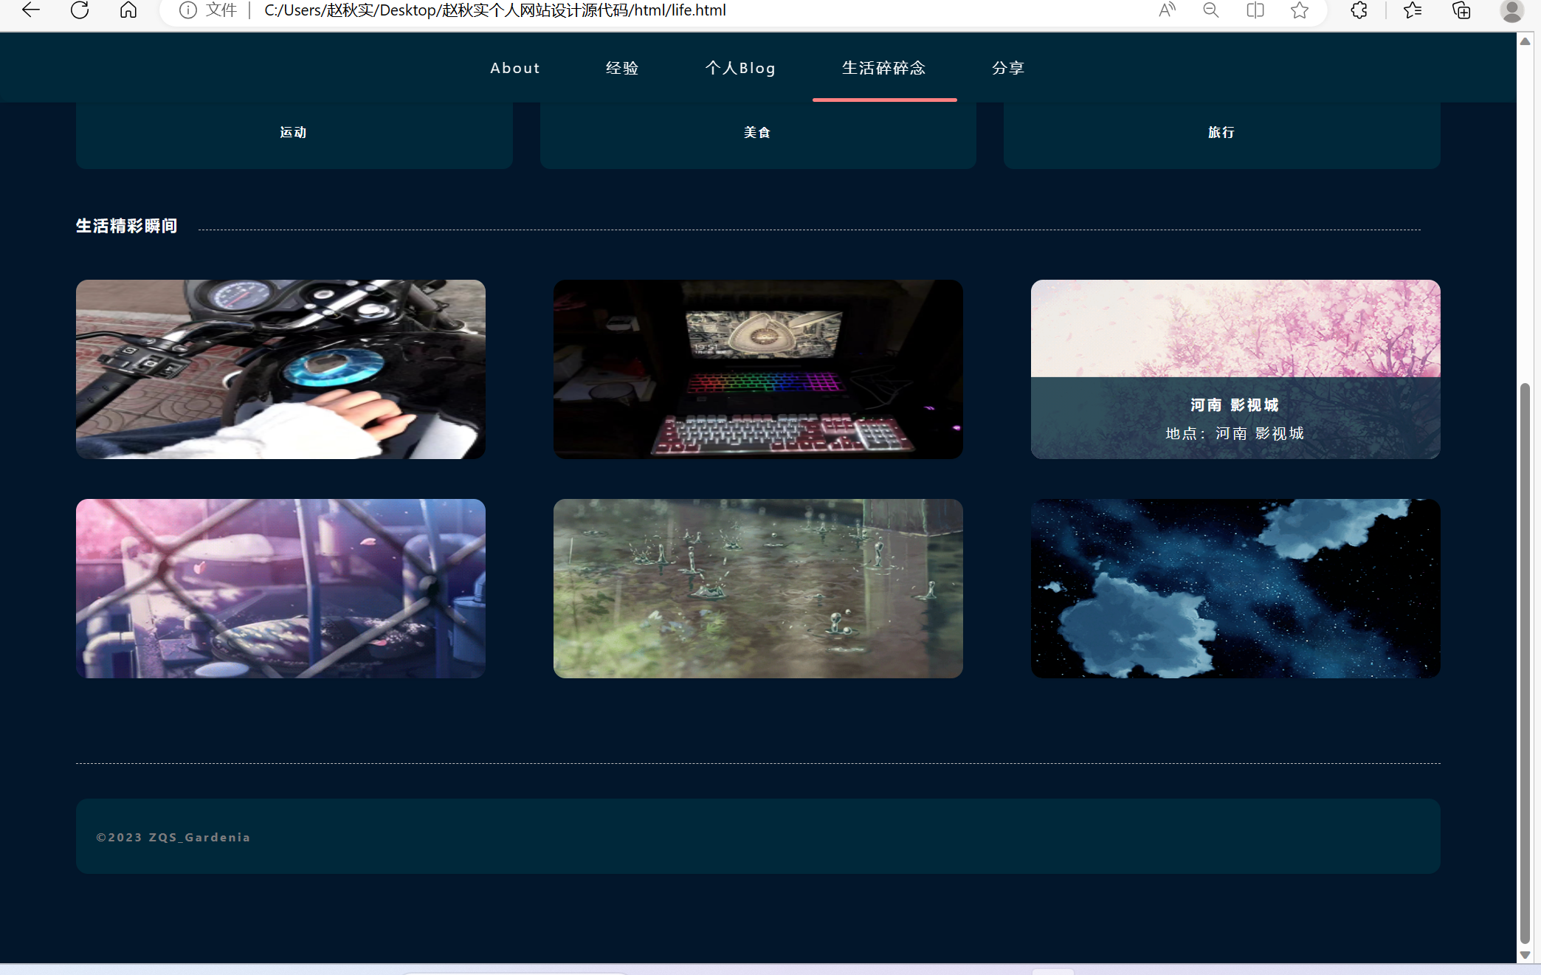

鼠标移动到上面6个图片上，会有介绍弹窗弹出的动画效果：

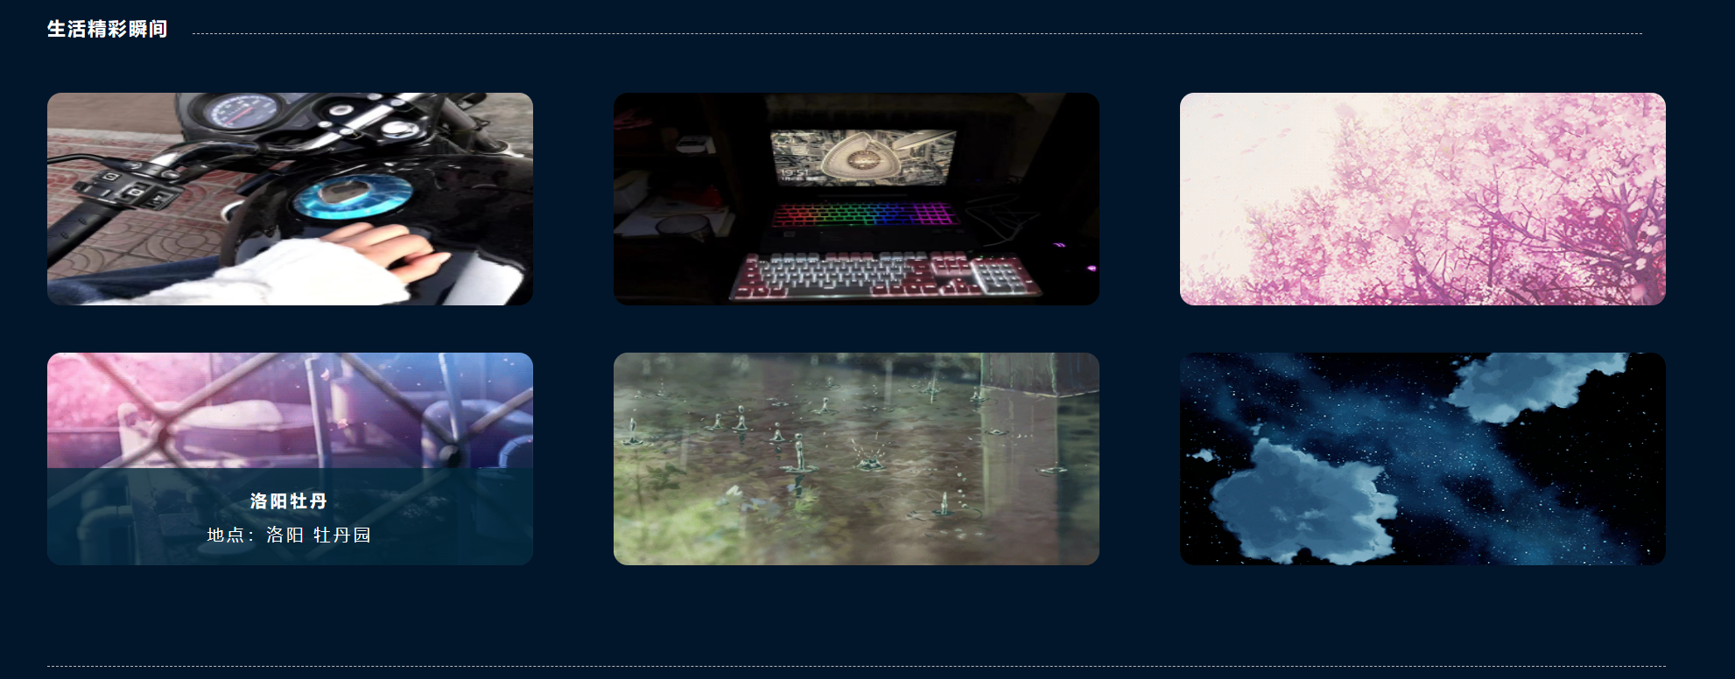

### 页面5：分享【share.html】

设计互动界面，成果图如下：

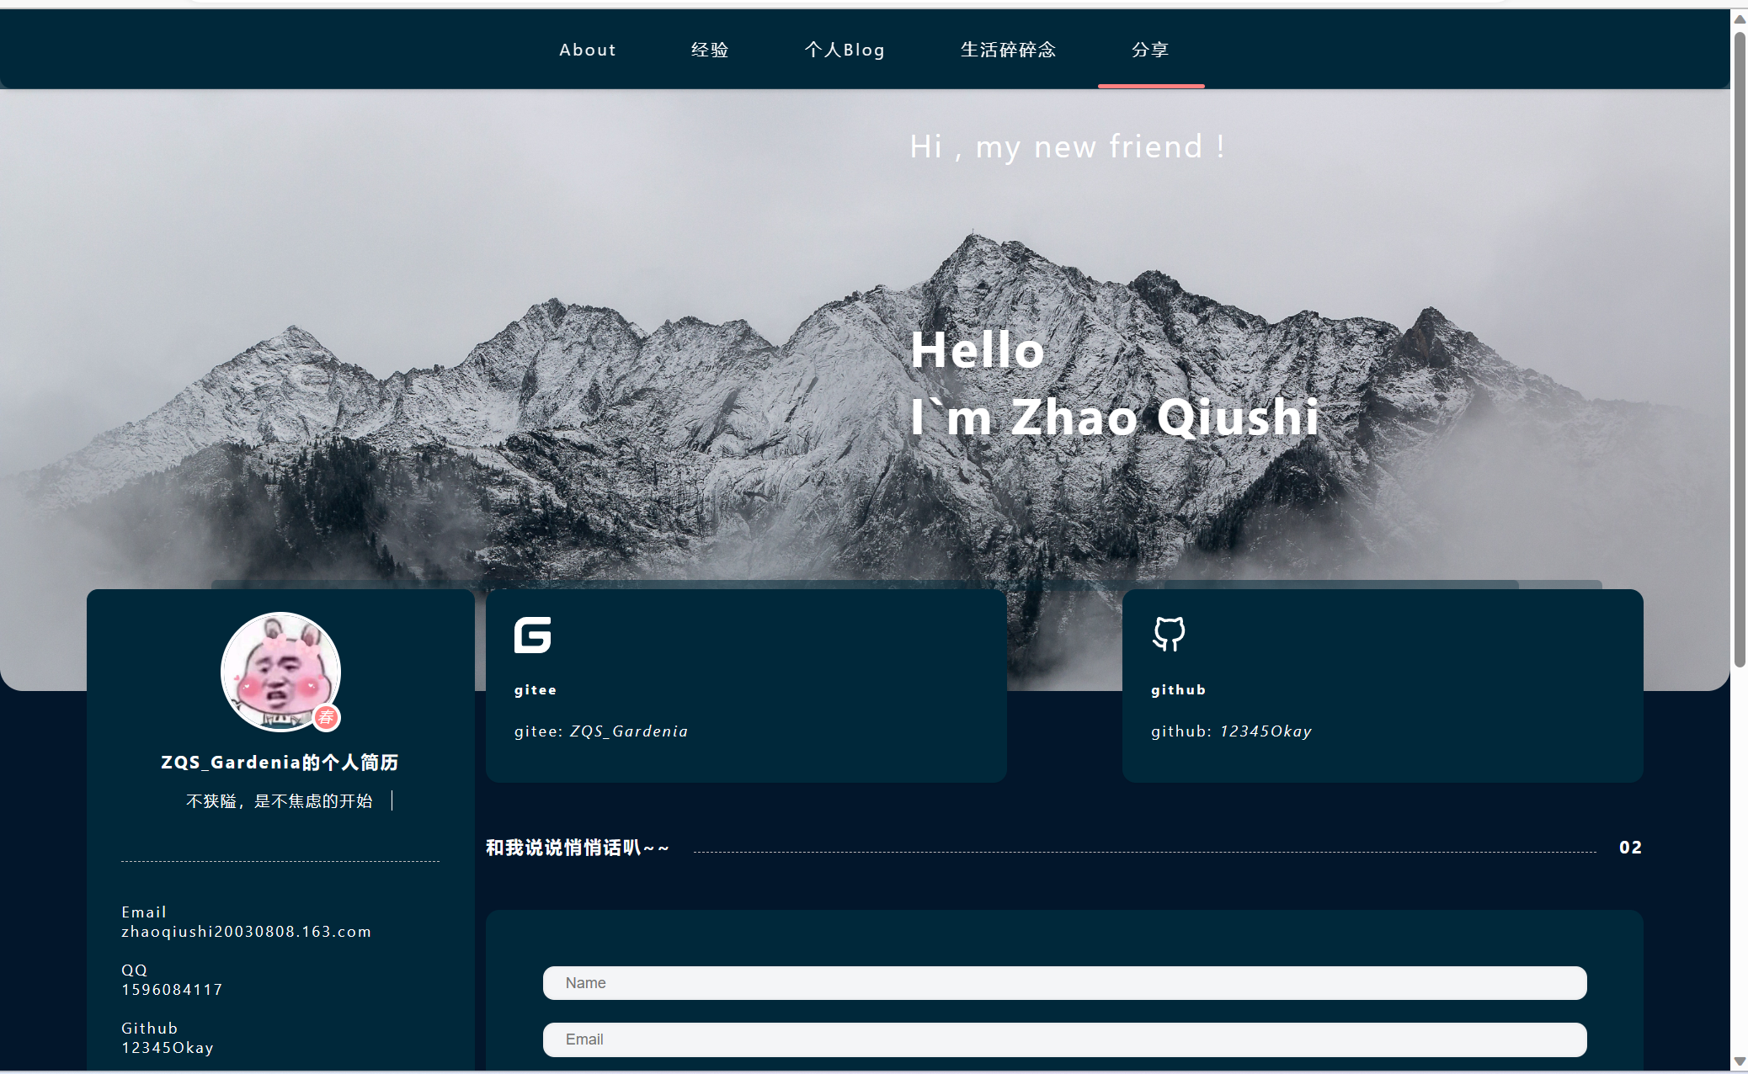

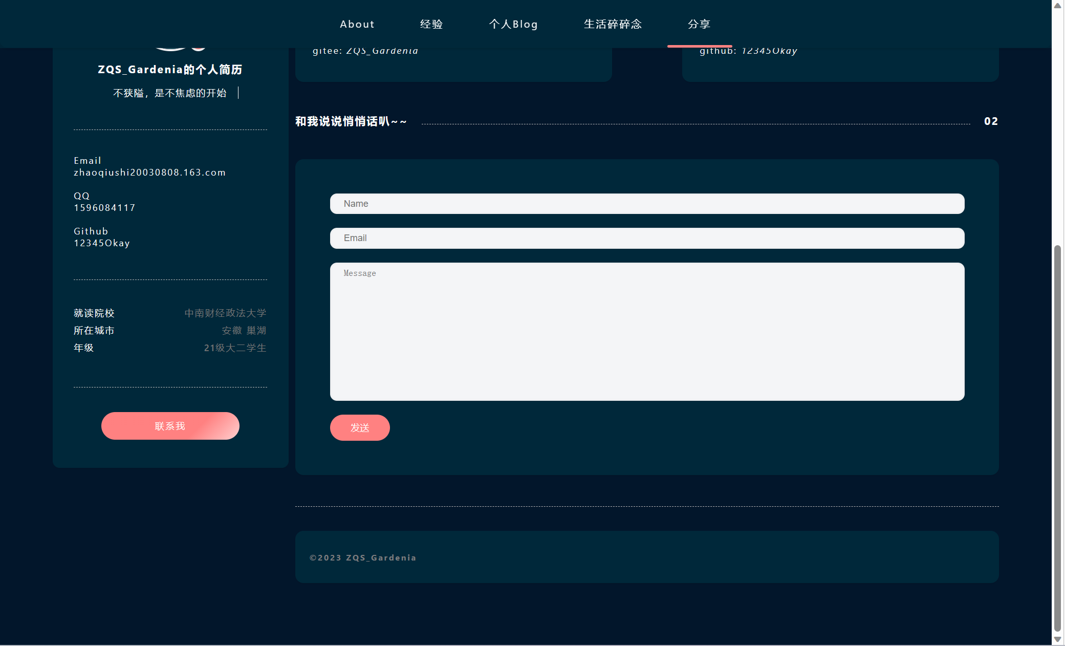

输入文本内容，有如下显示结果：

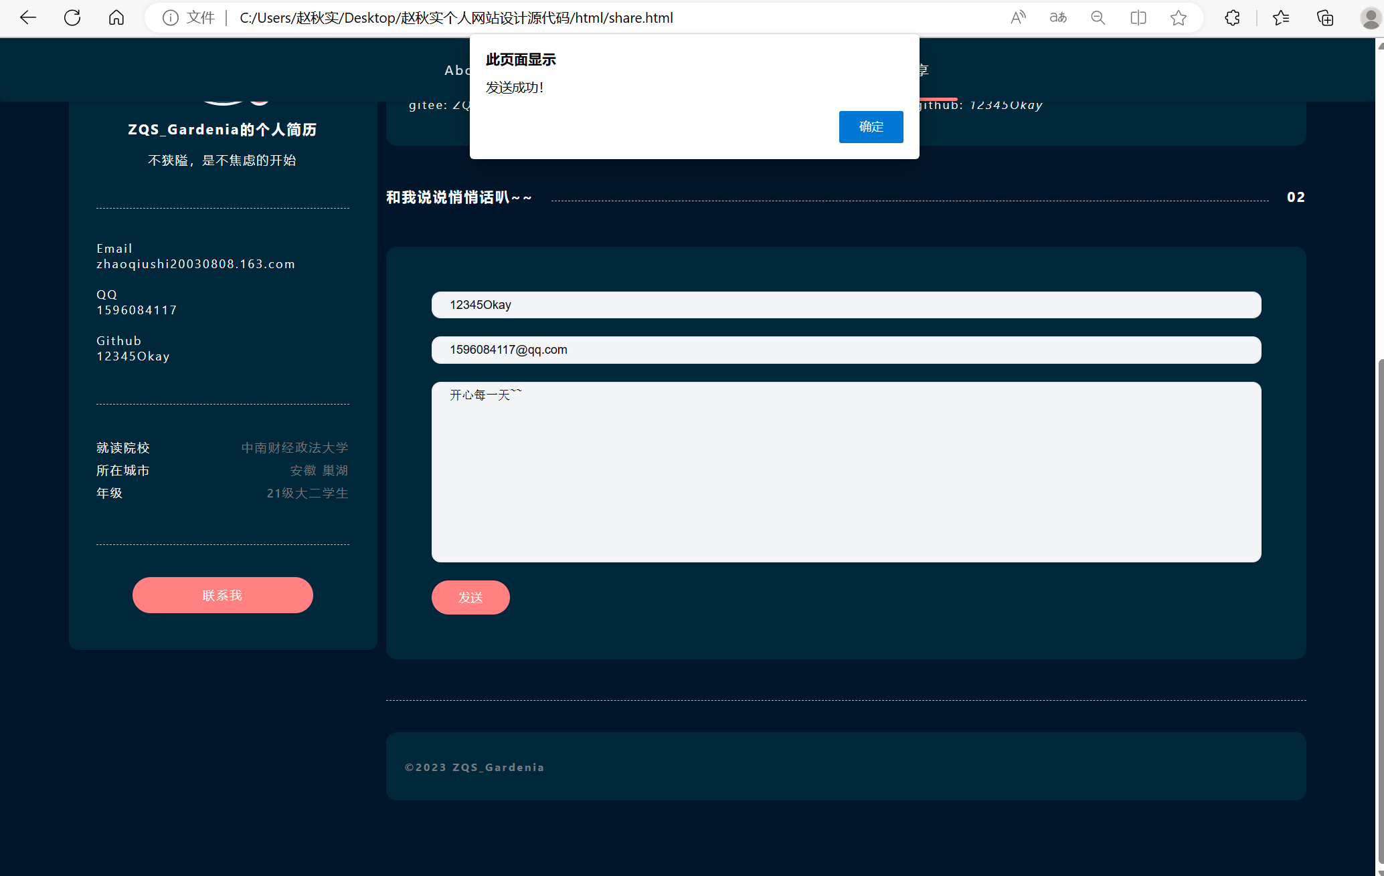

## 2. 布局与结构

### 页面基本布局与结构

#### 布局与结构说明

各个页面总体采用盒模型，结合各类定位方式进行框架布局，同时也综合运用了flexbox、表单布局等多种方式。所有页面基本包含3个逻辑区域：

* 顶部导航区 <div class="header">
* 个人网站封面，位于导航区下方 <div class="navigation">
* 主要内容区，包含左边区域和右边区域 <div class="content">

##### 1. 顶部导航区

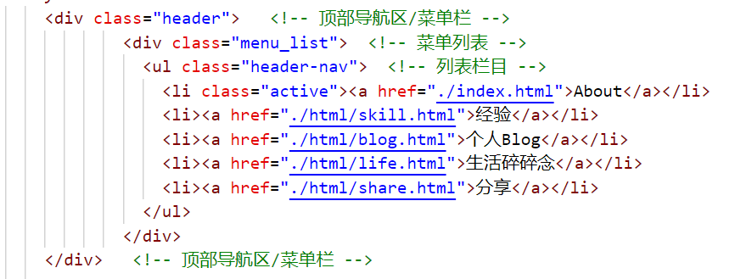

##### 2. 个人网站封面

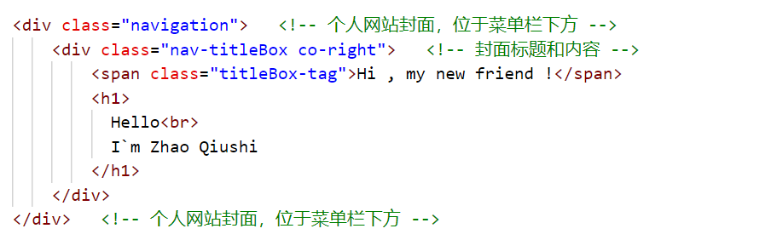

##### 3. 主要内容区

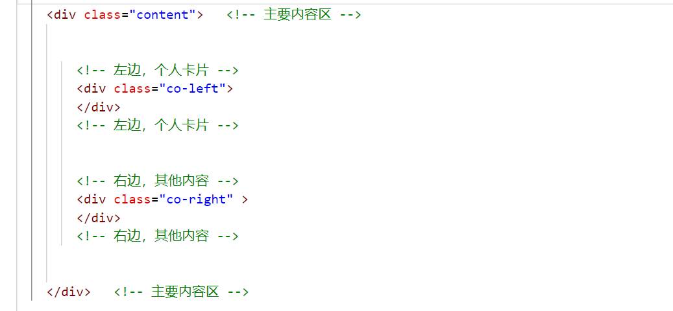

##### html文件布局与结构大纲如图所示：

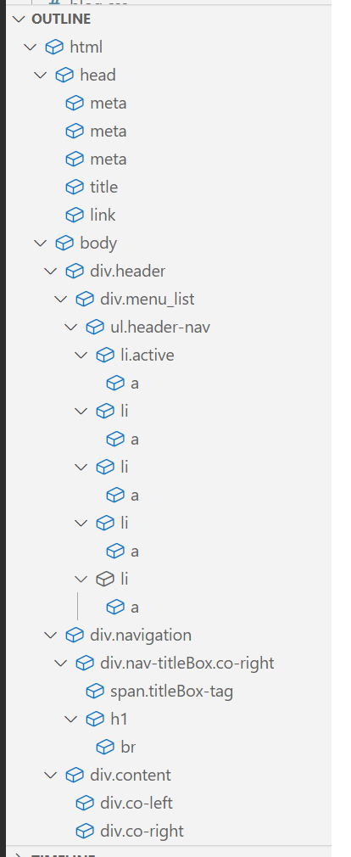

#### 布局框架实现

测试布局框架的代码对应2个文件：

* index-test.html
* base-test.css

index-test.html定义页面结构与布局，包含多个div，将基本框架建立起来；base-test.css细化各个逻辑区域的大小、背景等，并且设置背景颜色用以测试。下面展示关键代码：

##### 【index-test.html】

<div class="header"> <!-- 顶部导航区/菜单栏 -->

<div class="menu_list"> <!-- 菜单列表 -->

<ul class="header-nav"> <!-- 列表栏目 -->

<li class="active"><a href="./index.html">About</a></li>

<li><a href="./html/skill.html">经验</a></li>

<li><a href="./html/blog.html">个人Blog</a></li>

<li><a href="./html/life.html">生活碎碎念</a></li>

<li><a href="./html/share.html">分享</a></li>

</ul>

</div>

</div> <!-- 顶部导航区/菜单栏 -->

<div class="navigation"> <!-- 个人网站封面，位于菜单栏下方 -->

<div class="nav-titleBox co-right"> <!-- 封面标题和内容 -->

<span class="titleBox-tag">Hi , my new friend !</span>

<h1>

Hello<br>

I`m Zhao Qiushi

</h1>

</div>

</div> <!-- 个人网站封面，位于菜单栏下方 -->

<div class="content"> <!-- 主要内容区 -->

<!-- 左边，个人卡片 -->

<div class="co-left">

</div>

<!-- 左边，个人卡片 -->

<!-- 右边，其他内容 -->

<div class="co-right" >

</div>

<!-- 右边，其他内容 -->

</div> <!-- 主要内容区 -->

##### 【base-test.css】

/* 网页基本样式 */

body {

position: relative;

margin: 0px;

width: 100%;

padding: 0px;

font-size: 13px;

letter-spacing: 2px;

font-weight: 400;

font-family: -apple-system, BlinkMacSystemFont, "Segoe UI", Roboto, "Helvetica Neue", Arial, "Noto Sans", sans-serif, "Apple Color Emoji", "Segoe UI Emoji", "Segoe UI Symbol", "Noto Color Emoji";

color: white;

background-color:green;

}

/* 顶部导航区 */

.header {

position: fixed;

top: 0px;

width: 100%;

height: 100px;

line-height: 100px;

background-color: red;

border-radius: 0% 0% 10px 10px;

box-shadow: 0 2px 4px 0 rgb(0 0 0 / 15%);

}

/* 顶部导航区菜单栏 */

.menu_list {

position: absolute;

left: 0;

right: 0;

text-align: center;

background-color: yellow;

}

ul {

list-style: none;

margin: 0px;

padding: 0px;

}

ul>li {

display: inline-block;

font-size: 20px;

}

.header-nav {

display: inline-block;

}

.header-nav>li {

padding: 0 30px;

position: relative;

box-sizing: border-box;

}

a{

text-decoration: none;

color: red;

}

a:hover {

color: black;

}

.header-nav>li.active::after {

content: '';

display: inline-block;

position: absolute;

bottom: 0;

left: 0px;

right: 0px;

border-radius: 10px;

height: 4px;

background-color: purple;

}

/* 个人网站封面 */

/* 主题背景 */

.navigation {

margin: 0px auto 0;

width: 100%;

background-color: black;

height: 600px;

border-radius: 20px;

background-attachment: fixed;

background-size: 100%;

background-repeat: no-repeat;

color: #fff;

}

.navigation>.nav-titleBox {

margin-top: 100px;

margin-left: 800px;

}

.navigation .titleBox-tag {

font-size: 28px;

}

.navigation h1 {

margin: 130px 0;

font-size: 2.8rem;

text-shadow: 0 1px 10px rgb(0 0 0 / 30%);

}

/* 主要内容区 */

.content {

position: relative;

top: -90px;

min-height: 600px;

width: 90%;

margin: 0 auto;

display: flex;

background-color: pink;

}

.co-left {

width:25%;

display: inline-block;

background-color:red;

min-height: 50px;

}

.co-right {

width: 75%;

display: inline-block;

background-color: blue;

min-height: 50px;

margin-left: 10px;

}

/* 左半部分 */

.content .me-card {

width: fit-content;

min-width: 280px;

min-height: 650px;

border-radius: 10px;

text-align: center;

border: 1px solid black;

padding: 0px 30px;

}

/* 右半部分 */

/* 由于各个页面展现内容不同，此处不设置统一的css样式，每个页面都有对应的css文件 */

#### 布局测试图

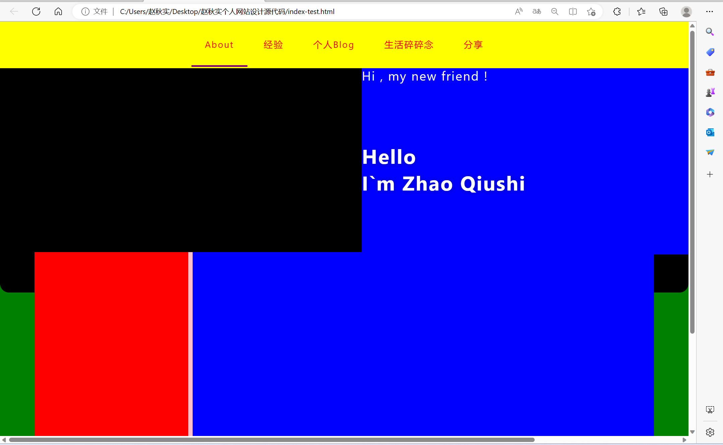

### 布局详解——以About【index.html】布局设计为例

#### 布局与结构说明

以基本页面布局为基础，继续划分逻辑区域，将“主要内容区”细分为左边的“个人卡片”和右边的“其他内容”两个区域，其中，“个人卡片”包含4个部分，每部分以分割线隔开，“其他内容”包括4个内容部分和1个底部标识部分。

总体布局如下：

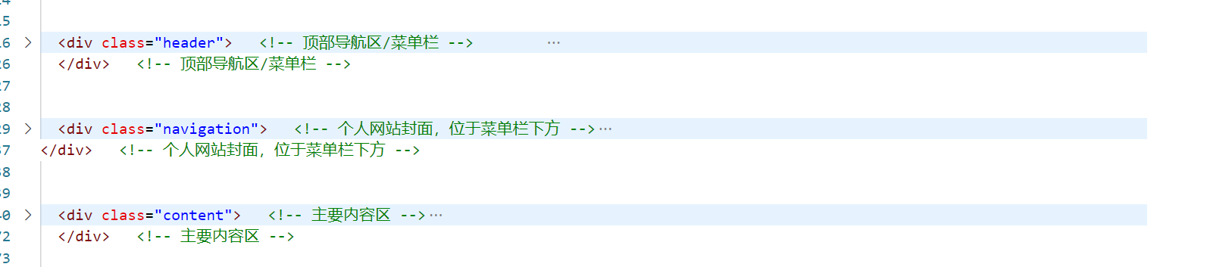

“主要内容区”结构如下：

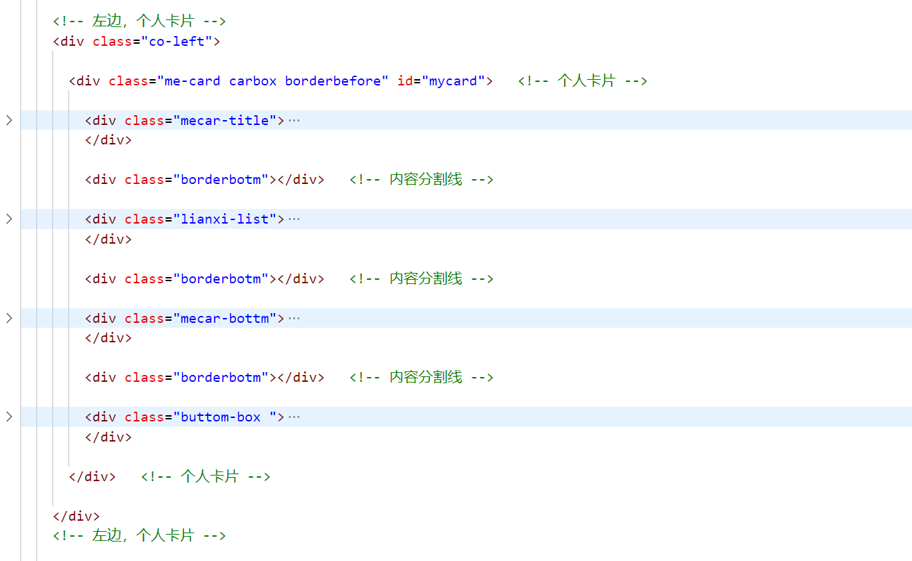

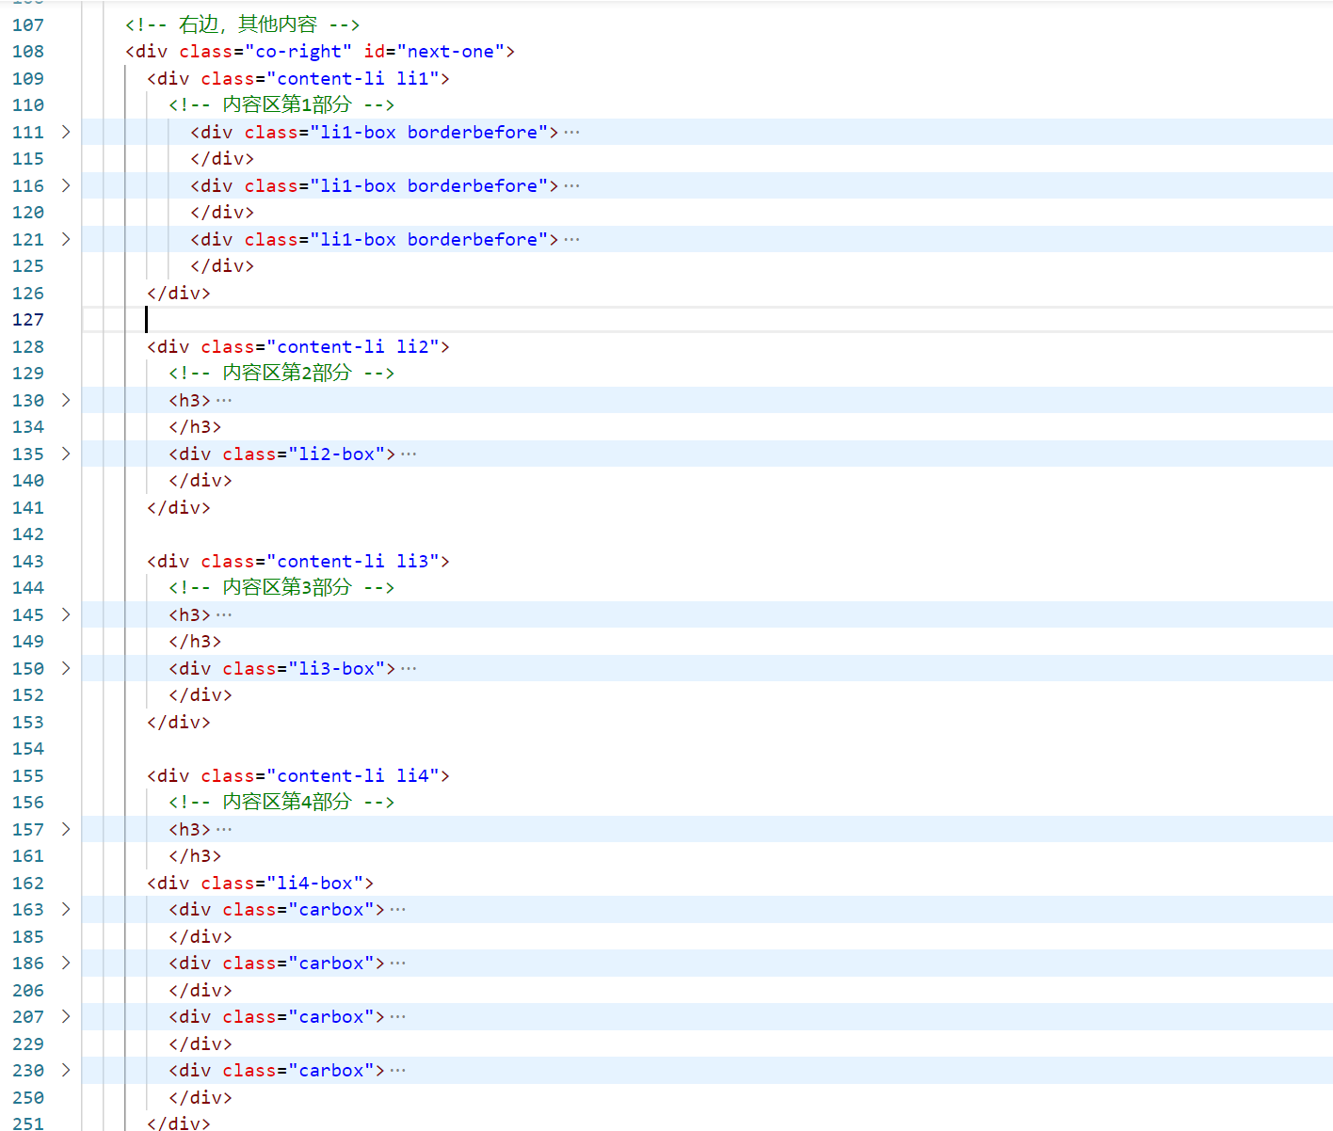

**html文件布局与结构大纲如图所示：**

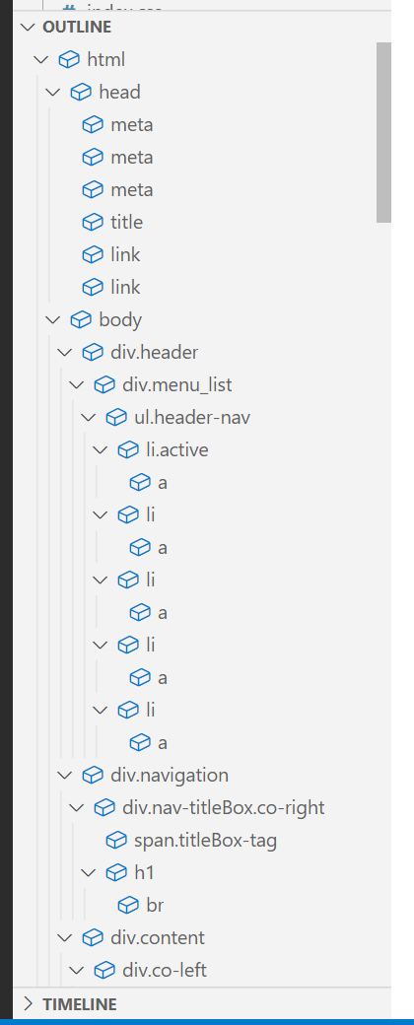 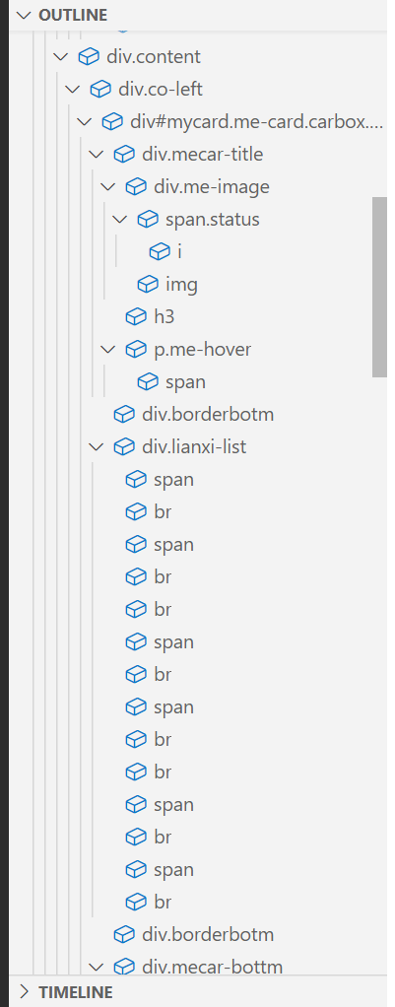 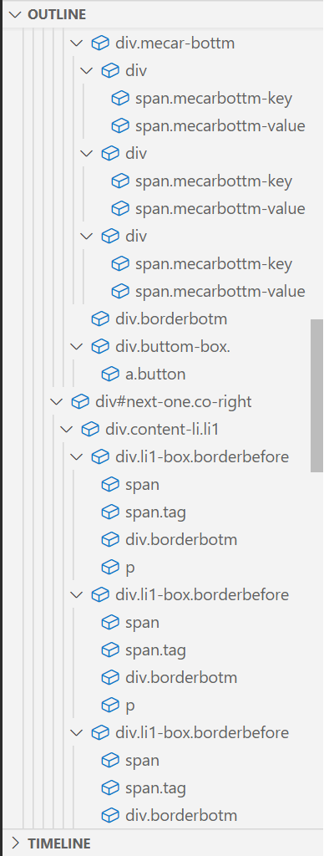

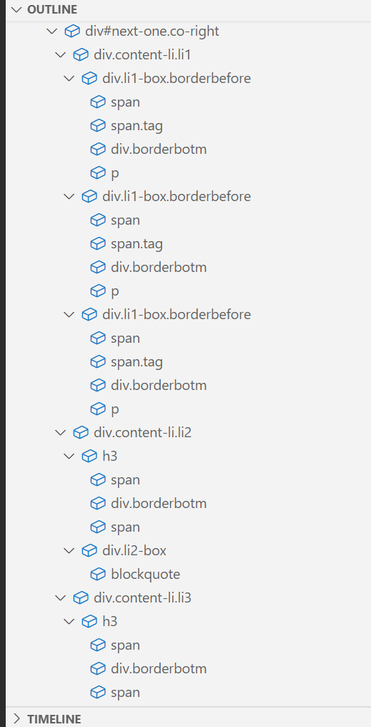 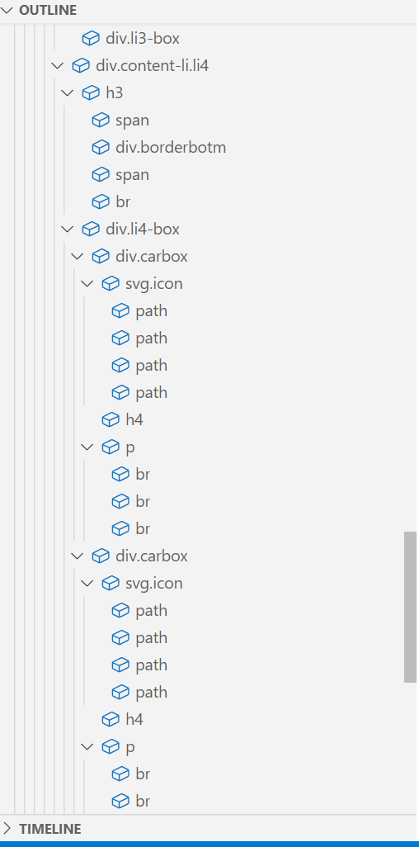 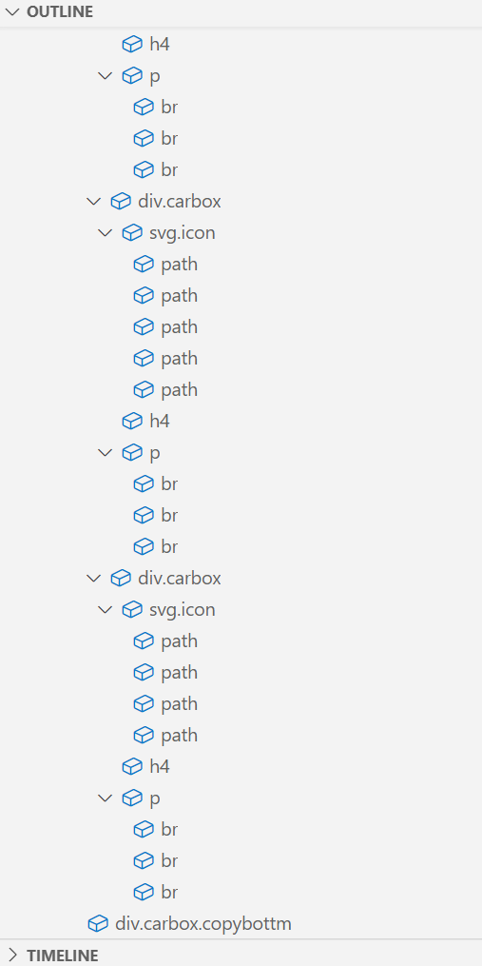

#### 布局框架实现

实现页面1布局框架的代码对应3个文件：

* index.html
* base.css
* index.css

index.html是以index-test.html文件为基础的，布局与结构大致相同，index.html需要链接到base.css和index.css文件。

下面展示【index.html】的全部代码和2个css文件的部分关键代码，解释网站设计中用到的布局思路：

##### 【index.html】

<!DOCTYPE html>

<html lang="en">

<head>

<meta charset="UTF-8">

<meta http-equiv="X-UA-Compatible" content="IE=edge">

<meta name="viewport" content="width=device-width, initial-scale=1.0">

<title>赵秋实_Gardenia</title> <!-- 修改个人网站名称为 赵秋实_Gardenia -->

<link rel="stylesheet" href="./css/base.css"> <!-- 链接 base.css 文件 -->

<link rel="stylesheet" href="./css/index.css"> <!-- 链接 index.css 文件 -->

</head>

<body>

<div class="header"> <!-- 顶部导航区/菜单栏 -->

<div class="menu_list"> <!-- 菜单列表 -->

<ul class="header-nav"> <!-- 列表栏目 -->

<li class="active"><a href="./index.html">About</a></li>

<li><a href="./html/skill.html">经验</a></li>

<li><a href="./html/blog.html">个人Blog</a></li>

<li><a href="./html/life.html">生活碎碎念</a></li>

<li><a href="./html/share.html">分享</a></li>

</ul>

</div>

</div> <!-- 顶部导航区/菜单栏 -->

<div class="navigation"> <!-- 个人网站封面，位于菜单栏下方 -->

<div class="nav-titleBox co-right"> <!-- 封面标题和内容 -->

<span class="titleBox-tag">Hi , my new friend !</span>

<h1>

Hello<br>

I`m Zhao Qiushi

</h1>

</div>

</div> <!-- 个人网站封面，位于菜单栏下方 -->

<div class="content"> <!-- 主要内容区 -->

<!-- 左边，个人卡片 -->

<div class="co-left">

  <div class="me-card carbox borderbefore" id="mycard"> <!-- 个人卡片 -->

<div class="mecar-title">

<!-- 卡片第1部分 -->

<div class="me-image">

<span class="status">

<i>春华秋实</i>

</span>

<img src="./images/index/toux.jpg" alt="">

</div>

<h3>ZQS_Gardenia的个人简历</h3>

<p class="me-hover">

<span>不狭隘，是不焦虑的开始</span>

</p>

</div>

<div class="borderbotm"></div> <!-- 内容分割线 -->

<div class="lianxi-list">

<!-- 卡片第2部分 -->

<span>Email</span><br>

<span>zhaoqiushi20030808.163.com</span><br>

<br>

<span>QQ</span><br>

<span>1596084117</span><br>

<br>

<span>Github</span><br>

<span>12345Okay</span><br>

</div>

<div class="borderbotm"></div> <!-- 内容分割线 -->

<div class="mecar-bottm">

<!-- 卡片第3部分 -->

<div>

<span class="mecarbottm-key">就读院校</span>

<span class="mecarbottm-value">中南财经政法大学

</div>

<div>

<span class="mecarbottm-key">所在城市</span>

<span class="mecarbottm-value">安徽 巢湖</span>

</div>

<div>

<span class="mecarbottm-key">年级</span>

<span class="mecarbottm-value">21级大二学生</span>

</div>

</div>

<div class="borderbotm"></div> <!-- 内容分割线 -->

   <div class="buttom-box ">

<!-- 卡片第4部分 -->

<a class="button" href="Mailto:zhaoqiushi20030808.163.com?Subject=邮箱标题&Body=邮箱内容！">联系我</a>

</div>

</div> <!-- 个人卡片 -->

</div>

<!-- 左边，个人卡片 -->

<!-- 右边，其他内容 -->

<div class="co-right" id="next-one">

<div class="content-li li1">

<!-- 内容区第1部分 -->

<div class="li1-box borderbefore">

<span>20</span><span class="tag">+</span>

<div class="borderbotm"></div>

<p>完成的个人项目</p>

</div>

<div class="li1-box borderbefore">

<span>6</span><span class="tag">+</span>

<div class="borderbotm"></div>

<p>参与的团队项目</p>

</div>

<div class="li1-box borderbefore">

<span>6</span><span class="tag">+</span>

<div class="borderbotm"></div>

<p>获奖情况</p>

</div>

</div>

<div class="content-li li2">

<!-- 内容区第2部分 -->

<h3>

<span>我的座右铭</span>

<div class="borderbotm"></div>

<span>01</span>

</h3>

<div class="li2-box">

<blockquote>

I hope I could keep advancing and let my life shine as a precious stone.and let my life shine as a

precious stone.

</blockquote>

</div>

</div>

<div class="content-li li3">

<!-- 内容区第3部分 -->

<h3>

<span>生活照片</span>

<div class="borderbotm"></div>

<span>02</span>

</h3>

<div class="li3-box">

<!-- <img src="./images/index/-1dce48feaba700f8.jpg" alt="生活照片"> -->

</div>

</div>

   <div class="content-li li4">

<!-- 内容区第4部分 -->

<h3>

<span>我的能力</span>

<div class="borderbotm"></div>

<span>03</span><br>

</h3>

<div class="li4-box">

<div class="carbox">

<svg t="1649230330671" class="icon" viewBox="0 0 1024 1024" version="1.1"

xmlns="http://www.w3.org/2000/svg" p-id="1638" width="40" height="40">

<path

d="M488.96 506.88h40.96v307.2h-40.96zM803.84 737.28h-97.28c-45.056 0-81.92-36.864-81.92-81.92V502.272h40.96V655.36c0 22.528 18.432 40.96 40.96 40.96h97.28v40.96zM312.32 737.28H215.04v-40.96h97.28c22.528 0 40.96-18.432 40.96-40.96V502.272h40.96V655.36c0 45.056-36.864 81.92-81.92 81.92z"

fill="#254665" p-id="1639"></path>

<path

d="M509.44 942.08c-46.592 0-84.48-37.888-84.48-84.48S462.848 773.12 509.44 773.12s84.48 37.888 84.48 84.48-37.888 84.48-84.48 84.48z m0-128c-24.064 0-43.52 19.456-43.52 43.52s19.456 43.52 43.52 43.52 43.52-19.456 43.52-43.52-19.456-43.52-43.52-43.52zM171.52 798.72c-46.592 0-84.48-37.888-84.48-84.48S124.928 629.76 171.52 629.76 256 667.648 256 714.24 218.112 798.72 171.52 798.72z m0-128c-24.064 0-43.52 19.456-43.52 43.52s19.456 43.52 43.52 43.52 43.52-19.456 43.52-43.52-19.456-43.52-43.52-43.52zM847.36 798.72c-46.592 0-84.48-37.888-84.48-84.48s37.888-84.48 84.48-84.48 84.48 37.888 84.48 84.48-37.888 84.48-84.48 84.48z m0-128c-24.064 0-43.52 19.456-43.52 43.52s19.456 43.52 43.52 43.52 43.52-19.456 43.52-43.52-19.456-43.52-43.52-43.52z"

fill="#254665" p-id="1640"></path>

<path

d="M683.52 543.232H319.488c-90.112 0-163.328-73.216-163.328-163.328 0-90.112 73.216-163.328 163.328-163.328h7.68C344.064 138.752 413.696 81.92 495.616 81.92c69.632 0 132.608 42.496 159.232 105.472 9.728-1.536 19.456-2.56 29.184-2.56 98.816 0 179.2 80.384 179.2 179.2-0.512 98.816-80.896 179.2-179.712 179.2zM319.488 258.048c-67.584 0-122.368 54.784-122.368 122.368s54.784 122.368 122.368 122.368h364.544c76.288 0 138.24-61.952 138.24-138.24s-61.952-138.24-138.24-138.24c-12.288 0-24.576 1.536-36.864 5.12l-19.456 5.12-5.632-18.944C605.696 161.792 553.472 122.88 495.616 122.88c-68.096 0-124.416 51.2-131.584 118.784l-2.048 22.016-21.504-3.584c-7.168-1.536-14.336-2.048-20.992-2.048z"

fill="#254665" p-id="1641"></path>

<path

d="M655.36 640H307.2V424.96c0-33.792 27.648-61.44 61.44-61.44h348.16v215.04c0 33.792-27.648 61.44-61.44 61.44z"

fill="#254665" opacity=".18" p-id="1642"></path>

</svg>

<h4>UI设计</h4>

<p>

UI排版<br>

静态页面<br>

动画效果<br>

</p>

</div>

<div class="carbox">

<svg t="1649230368898" class="icon" viewBox="0 0 1024 1024" version="1.1"

xmlns="http://www.w3.org/2000/svg" p-id="1847" width="40" height="40">

<path

d="M153.6 460.8h-40.96V179.2c0-45.056 34.816-81.92 78.336-81.92H921.6v230.4h-40.96V138.24H190.976c-20.48 0-37.376 18.432-37.376 40.96v281.6zM843.776 783.36H112.64v-216.064h40.96V742.4h690.176c20.48 0 37.376-18.432 37.376-40.96v-141.824h40.96V701.44c-0.512 45.056-35.328 81.92-78.336 81.92zM220.16 885.76h593.92v40.96H220.16z"

fill="#254665" p-id="1848"></path>

<path

d="M418.304 388.096l17.408 83.968 27.648-83.968H481.28l24.576 82.432 16.384-82.432h36.864l-27.648 130.048h-39.424L470.528 455.68 450.56 518.144h-39.424l-29.696-130.048h36.864zM611.328 388.096l17.408 83.968 27.648-83.968h17.92l24.576 82.432 16.384-82.432h36.864l-27.648 130.048h-39.424L663.552 455.68l-19.968 62.464H604.16l-29.696-130.048h36.864zM804.352 388.096l17.408 83.968 27.648-83.968h17.92l24.576 82.432 16.384-82.432h36.864l-27.648 130.048h-39.424L856.576 455.68l-19.968 62.464h-39.424l-29.696-130.048h36.864z"

fill="#254665" p-id="1849"></path>

<path

d="M839.168 445.44h-512V179.2c0-33.792 27.648-61.44 61.44-61.44h512v266.24c0 33.792-27.648 61.44-61.44 61.44z"

fill="#254665" opacity=".18" p-id="1850"></path>

<path d="M496.64 762.88h40.96v143.36h-40.96z" fill="#254665" p-id="1851"></path>

</svg>

<h4>网页制作</h4>

<p>

HTML、css、Java、C++、SQL<br>

JS交互<br>

Javaweb<br>

</p>

</div>

<div class="carbox">

<svg t="1649230380175" class="icon" viewBox="0 0 1024 1024" version="1.1"

xmlns="http://www.w3.org/2000/svg" p-id="2002" width="40" height="40">

<path

d="M738.304 689.664h-59.392v-40.96h59.392c89.6 0 162.816-74.24 162.816-164.864 0-91.136-73.216-164.864-162.816-164.864-9.216 0-18.944 1.024-28.16 2.56l-21.504 3.584-2.048-22.016C677.376 211.968 602.112 143.36 512 143.36c-90.624 0-165.888 68.608-175.104 159.744l-2.048 22.016-21.504-3.584c-9.216-1.536-18.432-2.56-28.16-2.56-89.6 0-162.816 74.24-162.816 164.864 0 91.136 73.216 164.864 162.816 164.864h59.904v40.96H285.184c-112.128 0-203.776-92.672-203.776-205.824s91.136-205.824 203.776-205.824c4.608 0 9.728 0 14.336 0.512C319.488 176.64 407.04 102.4 511.488 102.4c104.96 0 192.512 74.24 212.48 175.616 4.608-0.512 9.216-0.512 14.336-0.512 112.128 0 203.776 92.672 203.776 205.824s-91.136 206.336-203.776 206.336z"

fill="#254665" p-id="2003"></path>

<path d="M574.464 679.936L512 617.984l-62.464 61.952-28.672-28.672 91.136-91.648 91.136 91.648z"

fill="#254665" p-id="2004"></path>

<path d="M491.52 614.4h40.96v171.52h-40.96z" fill="#254665" p-id="2005"></path>

<path

d="M512 928.768c-3.584 0-7.68-1.024-10.752-3.072l-187.392-119.296c-6.144-3.584-9.728-10.24-9.728-17.408v-239.104c0-7.168 3.584-13.312 9.728-17.408l187.392-119.296c6.656-4.096 15.36-4.096 22.016 0l187.392 119.296c6.144 3.584 9.728 10.24 9.728 17.408V788.48c0 7.168-3.584 13.312-9.728 17.408l-187.392 119.296c-3.584 2.56-7.68 3.584-11.264 3.584z m-166.912-151.552l166.912 106.496 166.912-106.496v-216.576L512 454.656l-166.912 106.496v216.064z m354.304 11.264z"

fill="#254665" p-id="2006"></path>

<path

d="M675.84 675.84H286.72V409.6c0-33.792 27.648-61.44 61.44-61.44h389.12v266.24c0 33.792-27.648 61.44-61.44 61.44z"

fill="#254665" opacity=".18" p-id="2007"></path>

</svg>

<h4>前端</h4>

<p>

vue框架<br>

UI框架<br>

uniapp小程序<br>

</p>

</div>

<div class="carbox">

<svg t="1649230391217" class="icon" viewBox="0 0 1024 1024" version="1.1"

xmlns="http://www.w3.org/2000/svg" p-id="2160" width="40" height="40">

<path

d="M512 942.08c-99.328 0-174.08-184.832-174.08-430.08s74.752-430.08 174.08-430.08 174.08 184.832 174.08 430.08-74.752 430.08-174.08 430.08z m0-819.2c-62.976 0-133.12 159.744-133.12 389.12s70.144 389.12 133.12 389.12 133.12-159.744 133.12-389.12-70.144-389.12-133.12-389.12z"

fill="#254665" p-id="2161"></path>

<path d="M102.4 491.52h814.592v40.96H102.4z" fill="#254665" p-id="2162"></path>

<path

d="M512 942.08c-85.504 0-167.936-25.088-239.104-72.192l22.528-33.792C359.936 878.592 434.688 901.12 512 901.12c214.528 0 389.12-174.592 389.12-389.12s-174.592-389.12-389.12-389.12-389.12 174.592-389.12 389.12c0 82.944 25.6 161.792 74.24 228.864l-33.28 24.064C110.08 691.2 81.92 603.648 81.92 512c0-237.056 193.024-430.08 430.08-430.08s430.08 193.024 430.08 430.08-193.024 430.08-430.08 430.08z"

fill="#254665" p-id="2163"></path>

<path

d="M860.16 793.6H419.84V496.64c0-33.792 27.648-61.44 61.44-61.44h440.32v296.96c0 33.792-27.648 61.44-61.44 61.44z"

fill="#254665" opacity=".18" p-id="2164"></path>

</svg>

<h4>后端</h4>

<p>

nodjes + express + mysql<br>

koa<br>

socket<br>

</p>

</div>

</div>

</div>

<!-- 底部标识 -->

<div class="carbox copybottm">

©2023 ZQS_Gardenia

</div>

<!-- 底部标识 -->

</div>

<!-- 右边，其他内容 -->

  </div> <!-- 主要内容区 -->

</body>

</html>

##### 【base.css】

/* 网页基本样式 */

body {

position: relative;

margin: 0px;

width: 100%;

padding: 0px;

font-size: 13px;

letter-spacing: 2px;

font-weight: 400;

font-family: -apple-system, BlinkMacSystemFont, "Segoe UI", Roboto, "Helvetica Neue", Arial, "Noto Sans", sans-serif, "Apple Color Emoji", "Segoe UI Emoji", "Segoe UI Symbol", "Noto Color Emoji";

/* color: white; */

/* background-color:green; */

color: var(--headerFont);

background-color:var(--bagColor);

}

position: relative; 是CSS中的一个定位属性。当给一个元素设置了position: relative;时，该元素的位置将相对于其正常位置进行偏移，但是不会影响其他元素的位置和布局。对于相对定位的元素，它的偏移不会影响其他元素的布局，其他元素在文档流中的位置依然保持不变。次序依然按HTML元素顺序由上至下依次排列。因此，这里使用相对定位实现自适应布局。

/* 顶部导航区 */

.header {

position: fixed;

z-index: 2;

top: 0px;

width: 100%;

height: 70px;

line-height: 70px;

/* background-color: red; */

background-color: var(--headerCOlor);

border-radius: 0% 0% 10px 10px;

box-shadow: 0 2px 4px 0 rgb(0 0 0 / 15%);

}

position: fixed; 也是CSS中的一个定位属性。当给一个元素设置了position: fixed;时，该元素的位置相对于浏览器视口固定，而不是相对于文档流中的位置。fixed定位的元素会永远保持在屏幕的相同位置，不受页面滚动影响。因此使用这种布局结构实现吸顶导航区的效果。

/* 顶部导航区菜单栏 */

.menu_list {

position: absolute;

left: 0;

right: 0;

text-align: center;

/* background-color: yellow; */

background-color: var(--headerhover);

}

ul {

list-style: none;

margin: 0px;

padding: 0px;

}

ul>li {

display: inline-block;

font-size: 15px;

}

.header-nav {

    display: inline-block;

  }

  .header-nav>li {

    padding: 0 30px;

    position: relative;

    box-sizing: border-box;

  }

这里对于顶部导航区菜单栏使用绝对定位，使其脱离当前文档流的控制。该元素的位置相对于顶部导航区（最近的已定位祖先元素）的位置进行偏移，同时其他元素的布局不会受到它的影响。

display: inline-block; 是CSS中的一个display属性值，用来指定元素以内联元素的方式呈现，并且可以使用盒子模型属性（如width、height、padding、margin等），在水平方向上堆叠起来形成一个块级元素。box-sizing: border-box;用于指定盒模型的尺寸计算方式。当使用box-sizing: border-box;时，元素尺寸包括元素的内容框、内边距和边框的宽度，但不包括元素外边距的宽度。上述代码主要实现让菜单选项水平分布的效果。

/* 个人网站封面 */

img {

width: 100%;

height: 100%;

vertical-align: middle;

}

/* 主题背景 */

.navigation {

/* margin: 100px 4px 0px 0px; */

margin: 0px auto 0;

width: 100%;

/* background-color: black; */

background-color: transparent;

height: 600px;

border-radius: 20px;

background-image: url("../images/index/a58cbbffd2aa49c1b1e99990be912f30.jpg");

background-attachment: fixed;

background-size: 100%;

background-repeat: no-repeat;

overflow: hidden;

color: #fff;

}

.navigation>.nav-titleBox {

margin-top: 100px;

margin-left: 800px;

/* margin-top: 18rem; */

/* text-align: center; */

}

.navigation .titleBox-tag {

font-size: 28px;

/* text-align: center; */

}

.navigation h1 {

margin: 130px 0;

font-size: 2.8rem;

text-shadow: 0 1px 10px rgb(0 0 0 / 30%);

}

/* 主要内容区 */

.content {

position: relative;

top: -90px;

min-height: 600px;

width: 90%;

margin: 0 auto;

display: flex;

/* background-color: pink; */

}

.co-left {

width:25%;

display: inline-block;

/* background-color:red; */

min-height: 50px;

}

.co-right {

width: 75%;

display: inline-block;

/* background-color: blue; */

min-height: 50px;

margin-left: 10px;

}

display: flex; 用于创建一个flex container，即一个flex容器元素。“主要内容区”采用flexbox布局，其中包含2个子元素——左半部分“个人卡片”和右半部分“其他内容”。通过设置flex容器的相关属性，可以定义flex item的排列方向、尺寸、对齐方式等布局属性，实现灵活的排版方式。

"display: inline-block;"将“个人卡片”元素和“其他内容”元素显示为行内块级元素。使用inline-block元素可以实现多个元素在同一行内并允许设置具体尺寸的效果。

##### 【index.css】

定义“主要内容区”的右半部分——“其他内容”的样式，采用flexbox布局，共有4个子元素作为弹性项，其中第四部分内部又采用了flexbox布局，这里仅展示第四部分的css代码：

/* 第四块 */

.li4-box {

display: flex;

justify-content: space-between;

flex-wrap: wrap;

}

.li4-box>div {

box-sizing: border-box;

padding: 25px;

flex: 0 0 48%;

min-height: 250px;

margin-bottom: 20px;

font-weight: 500;

letter-spacing: 0.1em;

-webkit-font-smoothing: antialiased;

}

.li4-box>div h4 {

font-size: 27px;

/* color: #7B7B7D; */

text-align: left;

margin-left: 30px;

}

.li4-box>div p {

font-size: 20px;

color: #7B7B7D;

text-align: left;

margin-left: 30px;

}

.li4-box svg path{

fill: var(--headerFont);

}

.icon {

width: 45px;

height: 45px;

}

"display: flex;"将元素设置为flex container（弹性容器），"justify-content: space-between;" 和 "flex-wrap: wrap;" 都是flexbox布局的属性。

结合以上三个属性，以上面的设置为例，可实现将一组flex items自动排列在多行中，并让每一行的第一个和最后一个flex item紧贴父容器两侧，而中间的flex items则平均分布在每一行中间，整个布局更加紧凑美观。

## 3. HTML与CSS

### 3.1 HTML代码

#### 页面1 HTML【index.html】

<!DOCTYPE html>

<html lang="en">

<head>

<meta charset="UTF-8">

<meta http-equiv="X-UA-Compatible" content="IE=edge">

<meta name="viewport" content="width=device-width, initial-scale=1.0">

<title>赵秋实_Gardenia</title> <!-- 修改个人网站名称为 赵秋实_Gardenia -->

<link rel="stylesheet" href="./css/base.css"> <!-- 链接 base.css 文件 -->

<link rel="stylesheet" href="./css/index.css"> <!-- 链接 index.css 文件 -->

</head>

<body>

<div class="header"> <!-- 顶部导航区/菜单栏 -->

<div class="menu_list"> <!-- 菜单列表 -->

<ul class="header-nav"> <!-- 列表栏目 -->

<li class="active"><a href="./index.html">About</a></li>

<li><a href="./html/skill.html">经验</a></li>

<li><a href="./html/blog.html">个人Blog</a></li>

<li><a href="./html/life.html">生活碎碎念</a></li>

<li><a href="./html/share.html">分享</a></li>

</ul>

</div>

</div> <!-- 顶部导航区/菜单栏 -->

<div class="navigation"> <!-- 个人网站封面，位于菜单栏下方 -->

<div class="nav-titleBox co-right"> <!-- 封面标题和内容 -->

<span class="titleBox-tag">Hi , my new friend !</span>

<h1>

Hello<br>

I`m Zhao Qiushi

</h1>

</div>

</div> <!-- 个人网站封面，位于菜单栏下方 -->

<div class="content"> <!-- 主要内容区 -->

<!-- 左边，个人卡片 -->

<div class="co-left">

<div class="me-card carbox borderbefore" id="mycard"> <!-- 个人卡片 -->

<div class="mecar-title">

<!-- 卡片第1部分 -->

<div class="me-image">

<span class="status">

<i>春华秋实</i>

</span>

<img src="./images/index/toux.jpg" alt="">

</div>

<h3>ZQS_Gardenia的个人简历</h3>

<p class="me-hover">

<span>不狭隘，是不焦虑的开始</span>

</p>

</div>

<div class="borderbotm"></div> <!-- 内容分割线 -->

<div class="lianxi-list">

<!-- 卡片第2部分 -->

<span>Email</span><br>

<span>zhaoqiushi20030808.163.com</span><br>

<br>

<span>QQ</span><br>

<span>1596084117</span><br>

<br>

<span>Github</span><br>

<span>12345Okay</span><br>

</div>

<div class="borderbotm"></div> <!-- 内容分割线 -->

<div class="mecar-bottm">

<!-- 卡片第3部分 -->

<div>

<span class="mecarbottm-key">就读院校</span>

<span class="mecarbottm-value">中南财经政法大学

</div>

<div>

<span class="mecarbottm-key">所在城市</span>

<span class="mecarbottm-value">安徽 巢湖</span>

</div>

<div>

<span class="mecarbottm-key">年级</span>

<span class="mecarbottm-value">21级大二学生</span>

</div>

</div>

<div class="borderbotm"></div> <!-- 内容分割线 -->

<div class="buttom-box ">

<!-- 卡片第4部分 -->

<a class="button" href="Mailto:zhaoqiushi20030808.163.com?Subject=邮箱标题&Body=邮箱内容！">联系我</a>

</div>

</div> <!-- 个人卡片 -->

</div>

<!-- 左边，个人卡片 -->

<!-- 右边，其他内容 -->

<div class="co-right" id="next-one">

<div class="content-li li1">

<!-- 内容区第1部分 -->

<div class="li1-box borderbefore">

<span>20</span><span class="tag">+</span>

<div class="borderbotm"></div>

<p>完成的个人项目</p>

</div>

<div class="li1-box borderbefore">

<span>6</span><span class="tag">+</span>

<div class="borderbotm"></div>

<p>参与的团队项目</p>

</div>

<div class="li1-box borderbefore">

<span>6</span><span class="tag">+</span>

<div class="borderbotm"></div>

<p>获奖情况</p>

</div>

</div>

<div class="content-li li2">

<!-- 内容区第2部分 -->

<h3>

<span>我的座右铭</span>

<div class="borderbotm"></div>

<span>01</span>

</h3>

<div class="li2-box">

<blockquote>

I hope I could keep advancing and let my life shine as a precious stone.and let my life shine as a

precious stone.

</blockquote>

</div>

</div>

<div class="content-li li3">

<!-- 内容区第3部分 -->

<h3>

<span>生活照片</span>

<div class="borderbotm"></div>

<span>02</span>

</h3>

<div class="li3-box">

<!-- <img src="./images/index/-1dce48feaba700f8.jpg" alt="生活照片"> -->

</div>

</div>

<div class="content-li li4">

<!-- 内容区第4部分 -->

<h3>

<span>我的能力</span>

<div class="borderbotm"></div>

<span>03</span><br>

</h3>

<div class="li4-box">

<div class="carbox">

<svg t="1649230330671" class="icon" viewBox="0 0 1024 1024" version="1.1"

xmlns="http://www.w3.org/2000/svg" p-id="1638" width="40" height="40">

<path

d="M488.96 506.88h40.96v307.2h-40.96zM803.84 737.28h-97.28c-45.056 0-81.92-36.864-81.92-81.92V502.272h40.96V655.36c0 22.528 18.432 40.96 40.96 40.96h97.28v40.96zM312.32 737.28H215.04v-40.96h97.28c22.528 0 40.96-18.432 40.96-40.96V502.272h40.96V655.36c0 45.056-36.864 81.92-81.92 81.92z"

fill="#254665" p-id="1639"></path>

<path

d="M509.44 942.08c-46.592 0-84.48-37.888-84.48-84.48S462.848 773.12 509.44 773.12s84.48 37.888 84.48 84.48-37.888 84.48-84.48 84.48z m0-128c-24.064 0-43.52 19.456-43.52 43.52s19.456 43.52 43.52 43.52 43.52-19.456 43.52-43.52-19.456-43.52-43.52-43.52zM171.52 798.72c-46.592 0-84.48-37.888-84.48-84.48S124.928 629.76 171.52 629.76 256 667.648 256 714.24 218.112 798.72 171.52 798.72z m0-128c-24.064 0-43.52 19.456-43.52 43.52s19.456 43.52 43.52 43.52 43.52-19.456 43.52-43.52-19.456-43.52-43.52-43.52zM847.36 798.72c-46.592 0-84.48-37.888-84.48-84.48s37.888-84.48 84.48-84.48 84.48 37.888 84.48 84.48-37.888 84.48-84.48 84.48z m0-128c-24.064 0-43.52 19.456-43.52 43.52s19.456 43.52 43.52 43.52 43.52-19.456 43.52-43.52-19.456-43.52-43.52-43.52z"

fill="#254665" p-id="1640"></path>

<path

d="M683.52 543.232H319.488c-90.112 0-163.328-73.216-163.328-163.328 0-90.112 73.216-163.328 163.328-163.328h7.68C344.064 138.752 413.696 81.92 495.616 81.92c69.632 0 132.608 42.496 159.232 105.472 9.728-1.536 19.456-2.56 29.184-2.56 98.816 0 179.2 80.384 179.2 179.2-0.512 98.816-80.896 179.2-179.712 179.2zM319.488 258.048c-67.584 0-122.368 54.784-122.368 122.368s54.784 122.368 122.368 122.368h364.544c76.288 0 138.24-61.952 138.24-138.24s-61.952-138.24-138.24-138.24c-12.288 0-24.576 1.536-36.864 5.12l-19.456 5.12-5.632-18.944C605.696 161.792 553.472 122.88 495.616 122.88c-68.096 0-124.416 51.2-131.584 118.784l-2.048 22.016-21.504-3.584c-7.168-1.536-14.336-2.048-20.992-2.048z"

fill="#254665" p-id="1641"></path>

<path

d="M655.36 640H307.2V424.96c0-33.792 27.648-61.44 61.44-61.44h348.16v215.04c0 33.792-27.648 61.44-61.44 61.44z"

fill="#254665" opacity=".18" p-id="1642"></path>

</svg>

<h4>UI设计</h4>

<p>

UI排版<br>

静态页面<br>

动画效果<br>

</p>

</div>

<div class="carbox">

<svg t="1649230368898" class="icon" viewBox="0 0 1024 1024" version="1.1"

xmlns="http://www.w3.org/2000/svg" p-id="1847" width="40" height="40">

<path

d="M153.6 460.8h-40.96V179.2c0-45.056 34.816-81.92 78.336-81.92H921.6v230.4h-40.96V138.24H190.976c-20.48 0-37.376 18.432-37.376 40.96v281.6zM843.776 783.36H112.64v-216.064h40.96V742.4h690.176c20.48 0 37.376-18.432 37.376-40.96v-141.824h40.96V701.44c-0.512 45.056-35.328 81.92-78.336 81.92zM220.16 885.76h593.92v40.96H220.16z"

fill="#254665" p-id="1848"></path>

<path

d="M418.304 388.096l17.408 83.968 27.648-83.968H481.28l24.576 82.432 16.384-82.432h36.864l-27.648 130.048h-39.424L470.528 455.68 450.56 518.144h-39.424l-29.696-130.048h36.864zM611.328 388.096l17.408 83.968 27.648-83.968h17.92l24.576 82.432 16.384-82.432h36.864l-27.648 130.048h-39.424L663.552 455.68l-19.968 62.464H604.16l-29.696-130.048h36.864zM804.352 388.096l17.408 83.968 27.648-83.968h17.92l24.576 82.432 16.384-82.432h36.864l-27.648 130.048h-39.424L856.576 455.68l-19.968 62.464h-39.424l-29.696-130.048h36.864z"

fill="#254665" p-id="1849"></path>

<path

d="M839.168 445.44h-512V179.2c0-33.792 27.648-61.44 61.44-61.44h512v266.24c0 33.792-27.648 61.44-61.44 61.44z"

fill="#254665" opacity=".18" p-id="1850"></path>

<path d="M496.64 762.88h40.96v143.36h-40.96z" fill="#254665" p-id="1851"></path>

</svg>

<h4>网页制作</h4>

<p>

HTML、css、Java、C++、SQL<br>

JS交互<br>

Javaweb<br>

</p>

</div>

<div class="carbox">

<svg t="1649230380175" class="icon" viewBox="0 0 1024 1024" version="1.1"

xmlns="http://www.w3.org/2000/svg" p-id="2002" width="40" height="40">

<path

d="M738.304 689.664h-59.392v-40.96h59.392c89.6 0 162.816-74.24 162.816-164.864 0-91.136-73.216-164.864-162.816-164.864-9.216 0-18.944 1.024-28.16 2.56l-21.504 3.584-2.048-22.016C677.376 211.968 602.112 143.36 512 143.36c-90.624 0-165.888 68.608-175.104 159.744l-2.048 22.016-21.504-3.584c-9.216-1.536-18.432-2.56-28.16-2.56-89.6 0-162.816 74.24-162.816 164.864 0 91.136 73.216 164.864 162.816 164.864h59.904v40.96H285.184c-112.128 0-203.776-92.672-203.776-205.824s91.136-205.824 203.776-205.824c4.608 0 9.728 0 14.336 0.512C319.488 176.64 407.04 102.4 511.488 102.4c104.96 0 192.512 74.24 212.48 175.616 4.608-0.512 9.216-0.512 14.336-0.512 112.128 0 203.776 92.672 203.776 205.824s-91.136 206.336-203.776 206.336z"

fill="#254665" p-id="2003"></path>

<path d="M574.464 679.936L512 617.984l-62.464 61.952-28.672-28.672 91.136-91.648 91.136 91.648z"

fill="#254665" p-id="2004"></path>

<path d="M491.52 614.4h40.96v171.52h-40.96z" fill="#254665" p-id="2005"></path>

<path

d="M512 928.768c-3.584 0-7.68-1.024-10.752-3.072l-187.392-119.296c-6.144-3.584-9.728-10.24-9.728-17.408v-239.104c0-7.168 3.584-13.312 9.728-17.408l187.392-119.296c6.656-4.096 15.36-4.096 22.016 0l187.392 119.296c6.144 3.584 9.728 10.24 9.728 17.408V788.48c0 7.168-3.584 13.312-9.728 17.408l-187.392 119.296c-3.584 2.56-7.68 3.584-11.264 3.584z m-166.912-151.552l166.912 106.496 166.912-106.496v-216.576L512 454.656l-166.912 106.496v216.064z m354.304 11.264z"

fill="#254665" p-id="2006"></path>

<path

d="M675.84 675.84H286.72V409.6c0-33.792 27.648-61.44 61.44-61.44h389.12v266.24c0 33.792-27.648 61.44-61.44 61.44z"

fill="#254665" opacity=".18" p-id="2007"></path>

</svg>

<h4>前端</h4>

<p>

vue框架<br>

UI框架<br>

uniapp小程序<br>

</p>

</div>

<div class="carbox">

<svg t="1649230391217" class="icon" viewBox="0 0 1024 1024" version="1.1"

xmlns="http://www.w3.org/2000/svg" p-id="2160" width="40" height="40">

<path

d="M512 942.08c-99.328 0-174.08-184.832-174.08-430.08s74.752-430.08 174.08-430.08 174.08 184.832 174.08 430.08-74.752 430.08-174.08 430.08z m0-819.2c-62.976 0-133.12 159.744-133.12 389.12s70.144 389.12 133.12 389.12 133.12-159.744 133.12-389.12-70.144-389.12-133.12-389.12z"

fill="#254665" p-id="2161"></path>

<path d="M102.4 491.52h814.592v40.96H102.4z" fill="#254665" p-id="2162"></path>

<path

d="M512 942.08c-85.504 0-167.936-25.088-239.104-72.192l22.528-33.792C359.936 878.592 434.688 901.12 512 901.12c214.528 0 389.12-174.592 389.12-389.12s-174.592-389.12-389.12-389.12-389.12 174.592-389.12 389.12c0 82.944 25.6 161.792 74.24 228.864l-33.28 24.064C110.08 691.2 81.92 603.648 81.92 512c0-237.056 193.024-430.08 430.08-430.08s430.08 193.024 430.08 430.08-193.024 430.08-430.08 430.08z"

fill="#254665" p-id="2163"></path>

<path

d="M860.16 793.6H419.84V496.64c0-33.792 27.648-61.44 61.44-61.44h440.32v296.96c0 33.792-27.648 61.44-61.44 61.44z"

fill="#254665" opacity=".18" p-id="2164"></path>

</svg>

<h4>后端</h4>

<p>

nodjes + express + mysql<br>

koa<br>

socket<br>

</p>

</div>

</div>

</div>

<!-- 底部标识 -->

<div class="carbox copybottm">

©2023 ZQS_Gardenia

</div>

<!-- 底部标识 -->

</div>

<!-- 右边，其他内容 -->

</div> <!-- 主要内容区 -->

</body>

</html>

#### 页面2 HTML【skill.html】

<!DOCTYPE html>

<html lang="en">

<head>

<meta charset="UTF-8">

<meta http-equiv="X-UA-Compatible" content="IE=edge">

<meta name="viewport" content="width=device-width, initial-scale=1.0">

<title>经验</title> <!-- 修改个人网站名称为 经验 -->

<link rel="stylesheet" href="../css/base.css"> <!-- 链接 base.css 文件 -->

<link rel="stylesheet" href="../css/skill.css"> <!-- 链接 skill.css 文件 -->

</head>

<body>

<div class="header"> <!-- 顶部导航区/菜单栏 -->

<div class="menu_list"> <!-- 菜单列表 -->

<ul class="header-nav"> <!-- 列表栏目 -->

<li><a href="../index.html">About</a></li>

<li class="active"><a href="../html/skill.html">经验</a></li>

<li><a href="../html/blog.html">个人Blog</a></li>

<li><a href="../html/life.html">生活碎碎念</a></li>

<li><a href="../html/share.html">分享</a></li>

</ul>

</div>

</div> <!-- 顶部导航区/菜单栏 -->

<div class="navigation"> <!-- 个人网站封面，位于菜单栏下方 -->

<div class="nav-titleBox co-right"> <!-- 封面标题和内容 -->

<span class="titleBox-tag">Hi , my new friend !</span>

<h1>

Hello<br>

I`m Zhao Qiushi

</h1>

</div>

</div> <!-- 个人网站封面，位于菜单栏下方 -->

<!-- 主要修改部分 -->

<div class="content"> <!-- 主要内容区 -->

<!-- 左边，个人卡片 -->

<div class="co-left">

<div class="me-card carbox borderbefore" id="mycard"> <!-- 个人卡片 -->

<div class="mecar-title">

<!-- 卡片第1部分 -->

<div class="me-image">

<span class="status">

<i>春华秋实</i>

</span>

<img src="../images/index/toux.jpg" alt="">

</div>

<h3>ZQS_Gardenia的个人简历</h3>

<p class="me-hover">

<span>不狭隘，是不焦虑的开始</span>

</p>

</div>

<div class="borderbotm"></div> <!-- 内容分割线 -->

<div class="lianxi-list">

<!-- 卡片第2部分 -->

<span>Email</span><br>

<span>zhaoqiushi20030808.163.com</span><br>

<br>

<span>QQ</span><br>

<span>1596084117</span><br>

<br>

<span>Github</span><br>

<span>12345Okay</span><br>

</div>

<div class="borderbotm"></div> <!-- 内容分割线 -->

<div class="mecar-bottm">

<!-- 卡片第3部分 -->

<div>

<span class="mecarbottm-key">就读院校</span>

<span class="mecarbottm-value">中南财经政法大学

</div>

<div>

<span class="mecarbottm-key">所在城市</span>

<span class="mecarbottm-value">安徽 巢湖</span>

</div>

<div>

<span class="mecarbottm-key">年级</span>

<span class="mecarbottm-value">21级大二学生</span>

</div>

</div>

<div class="borderbotm"></div> <!-- 内容分割线 -->

<div class="buttom-box ">

<!-- 卡片第4部分 -->

<a class="button" href="Mailto:zhaoqiushi20030808.163.com?Subject=邮箱标题&Body=邮箱内容！">联系我</a>

</div>

</div> <!-- 个人卡片 -->

</div>

<!-- 左边，个人卡片 -->

<!-- 右边，其他内容 -->

<div class="co-right" id="next-one">

<div class="content-li li1">

<!-- 内容区第1部分 -->

<div class="li1-box ">

<div class="li1-box-item carbox borderbefore">

<div class="boxitem-line">

<h6>CSS<span>熟练</span></h6>

<div class="propress">

<span style="width: 50%;"></span>

<!-- <span class="jindu"></span> -->

</div>

</div>

<div class="boxitem-line">

<h6>sass<span>了解</span></h6>

<div class="propress">

<!-- <span class="jindu"></span> -->

<span style="width: 50%;"></span>

</div>

</div>

</div>

<div class="li1-box-item carbox borderbefore">

<div class="boxitem-line">

<h6>less<span>皮毛</span></h6>

<div class="propress">

<!-- <span class="jindu"></span> -->

<span style="width: 50%;"></span>

</div>

</div>

<div class="boxitem-line">

<h6>HTML<span>熟练</span></h6>

<div class="propress">

<!-- <span class="jindu"></span> -->

<span style="width: 50%;"></span>

</div>

</div>

</div>

<div class="li1-box-item carbox">

<div class="boxitem-line">

<h6>JS<span>了解</span></h6>

<div class="propress">

<!-- <span class="jindu"></span> -->

<span style="width: 50%;"></span>

</div>

</div>

<div class="boxitem-line">

<h6>JQ<span>皮毛</span></h6>

<div class="propress">

<!-- <span class="jindu"></span> -->

<span style="width: 50%;"></span>

</div>

</div>

</div>

<div class="li1-box-item carbox">

<div class="boxitem-line">

<h6>bootsrap<span>了解</span></h6>

<div class="propress">

<!-- <span class="jindu"></span> -->

<span style="width: 50%;"></span>

</div>

</div>

<div class="boxitem-line">

<h6>Element-ui<span>掌握</span></h6>

<div class="propress">

<!-- <span class="jindu"></span> -->

<span style="width: 50%;"></span>

</div>

</div>

</div>

<div class="li1-box-item carbox">

<div class="boxitem-line">

<h6>mint-ui<span>了解</span></h6>

<div class="propress">

<span style="width: 50%;"></span>

</div>

</div>

<div class="boxitem-line">

<h6>vant<span>精通（才怪）</span></h6>

<div class="propress">

<!-- <span class="jindu"></span> -->

<span style="width: 50%;"></span>

</div>

</div>

</div>

<div class="li1-box-item carbox">

<div class="boxitem-line">

<h6>Vue2<span>精通（才怪）</span></h6>

<div class="propress">

<!-- <span class="jindu"></span> -->

<span style="width: 50%;"></span>

</div>

</div>

<div class="boxitem-line">

<h6>react<span>了解</span></h6>

<div class="propress">

<!-- <span class="jindu"></span> -->

<span style="width: 50%;"></span>

</div>

</div>

</div>

</div>

</div>

<div class="content-li li2">

<h3>

<span>其他技能</span>

<div class="borderbotm"></div>

<span>02</span>

</h3>

<div class="carbox li2-box">

<ul>

<li>Photoshop</li>

<li>Adobe After Effects</li>

<li>Microsoft Office Word</li>

<li>Office Excel </li>

<li>Office PowerPoint</li>

</ul>

</div>

</div>

<div class="content-li li3">

<h3>

<span>学习经历</span>

<div class="borderbotm"></div>

<span>03</span>

</h3>

<div class="li3-box">

<div class="li3box-left">

<div class="li3box-pro">

<div class="carbox carcontent">

<h6>中南财经政法大学</h6>

<i>2021/9 - 2022/6</i>

<p>2021 - 2022学年国家奖学金 <br><br>

优秀学生干部 <br><br>

市调大赛省一 <br><br>

软件开发公司实习<br><br></p>

</div>

<div class="carprogress"></div>

</div>

<div class="li3box-pro">

<div class="carbox carcontent">

<h6>中南财经政法大学</h6>

<i>2022/6 - 至今</i>

<p>学习前端语言 <br><br>

构建页面 / 利用JS、CSS3等制作网站，vue有关项目 <br><br>

普通话二级甲等 <br><br>

三创赛校三<br><br></p>

</div>

<div class="carprogress"></div>

</div>

</div>

<div class="li3box-right">

<div class="li3box-pro">

<div class="carbox carcontent">

<h6>中南财经政法大学</h6>

<i>2021/9 - 2022/6</i>

<p>

学习java语言 <br><br>

利用Android、sql等制作app <br><br>

全国计算机等级二级证书 <br><br>

大创国家级、省级项目成功立项<br><br>

</p>

</div>

<div class="carprogress"></div>

</div>

<div class="li3box-pro">

<div class="carbox carcontent">

<h6>中南财经政法大学</h6>

<i>2022/6 - 至今</i>

<p>

校级“红旗团支部”负责人<br><br>

“百生讲坛”十佳团日活动负责人<br><br>

</p>

</div>

<div class="carprogress"></div>

</div>

<div class="li3box-pro">

<div class="carbox carcontent">

<h6>中南财经政法大学</h6>

<i>- 2021/9</i>

<p>

... ... ... 还是个高中生

</p>

</div>

<div class="carprogress"></div>

</div>

</div>

</div>

</div>

<div class="borderbotm"></div>

<!-- 底部标识 -->

<div class="carbox copybottm">

©2023 ZQS_Gardenia

</div>

<!-- 底部标识 -->

</div>

<!-- 右边，其他内容 -->

</div> <!-- 主要内容区 -->

</body>

</html>

#### 页面3 HTML【blog.html】

<!DOCTYPE html>

<html lang="en">

<head>

<meta charset="UTF-8">

<meta http-equiv="X-UA-Compatible" content="IE=edge">

<meta name="viewport" content="width=device-width, initial-scale=1.0">

<title>个人Blog</title> <!-- 修改个人网站名称为 个人Blog -->

<link rel="stylesheet" href="../css/base.css"> <!-- 链接 base.css 文件 -->

<link rel="stylesheet" href="../css/blog.css"> <!-- 链接 blog.css 文件 -->

</head>

<body>

<div class="header"> <!-- 顶部导航区/菜单栏 -->

<div class="menu_list"> <!-- 菜单列表 -->

<ul class="header-nav"> <!-- 列表栏目 -->

<li><a href="../index.html">About</a></li>

<li><a href="../html/skill.html">经验</a></li>

<li class="active"><a href="../html/blog.html">个人Blog</a></li>

<li><a href="../html/life.html">生活碎碎念</a></li>

<li><a href="../html/share.html">分享</a></li>

</ul>

</div>

</div> <!-- 顶部导航区/菜单栏 -->

<div class="navigation"> <!-- 个人网站封面，位于菜单栏下方 -->

<div class="nav-titleBox co-right"> <!-- 封面标题和内容 -->

<span class="titleBox-tag">Hi , my new friend !</span>

<h1>

Hello<br>

I`m Zhao Qiushi

</h1>

</div>

</div> <!-- 个人网站封面，位于菜单栏下方 -->

<!-- 主要修改部分 -->

<div class="content"> <!-- 主要内容区 -->

<!-- 左边，个人卡片 -->

<div class="co-left">

<div class="me-card carbox borderbefore" id="mycard"> <!-- 个人卡片 -->

<div class="mecar-title">

<!-- 卡片第1部分 -->

<div class="me-image">

<span class="status">

<i>春华秋实</i>

</span>

<img src="../images/index/toux.jpg" alt="">

</div>

<h3>ZQS_Gardenia的个人简历</h3>

<p class="me-hover">

<span>不狭隘，是不焦虑的开始</span>

</p>

</div>

<div class="borderbotm"></div> <!-- 内容分割线 -->

<div class="lianxi-list">

<!-- 卡片第2部分 -->

<span>Email</span><br>

<span>zhaoqiushi20030808.163.com</span><br>

<br>

<span>QQ</span><br>

<span>1596084117</span><br>

<br>

<span>Github</span><br>

<span>12345Okay</span><br>

</div>

<div class="borderbotm"></div> <!-- 内容分割线 -->

<div class="mecar-bottm">

<!-- 卡片第3部分 -->

<div>

<span class="mecarbottm-key">就读院校</span>

<span class="mecarbottm-value">中南财经政法大学

</div>

<div>

<span class="mecarbottm-key">所在城市</span>

<span class="mecarbottm-value">安徽 巢湖</span>

</div>

<div>

<span class="mecarbottm-key">年级</span>

<span class="mecarbottm-value">21级大二学生</span>

</div>

</div>

<div class="borderbotm"></div> <!-- 内容分割线 -->

<div class="buttom-box ">

<!-- 卡片第4部分 -->

<a class="button" href="Mailto:zhaoqiushi20030808.163.com?Subject=邮箱标题&Body=邮箱内容！">联系我</a>

</div>

</div> <!-- 个人卡片 -->

</div>

<!-- 左边，个人卡片 -->

<!-- 右边，其他内容 -->

<div class="co-right" id="next-one">

<div class="content-li li1">

<div class="li1-box borderbefore">

<svg t="1663164259401" class="icon" viewBox="0 0 1024 1024" version="1.1" xmlns="http://www.w3.org/2000/svg"

p-id="1936" width="30" height="30">

<path

d="M128 0l888.832 0-72.704 843.776-376.832 115.712-358.4-115.712zM839.68 254.976l21.504-128-572.416-1.024 36.864 384 372.736 0 0 100.352-124.928 44.032-130.048-46.08-8.192-54.272-102.4 1.024 15.36 135.168 219.136 76.8 230.4-72.704 29.696-309.248-405.504 0-10.24-130.048 428.032 0z"

p-id="1937"></path>

</svg>

<p>HTML、CSS、JS</p>

</div>

<div class="li1-box borderbefore">

<svg t="1663164308088" class="icon" viewBox="0 0 1024 1024" version="1.1" xmlns="http://www.w3.org/2000/svg"

p-id="2882" width="30" height="30">

<path

d="M377.642667 791.893333s-39.125333 22.784 27.861333 30.464c81.152 9.301333 122.624 7.978667 212.010667-9.002666 0 0 23.552 14.762667 56.362666 27.562666-200.490667 85.888-453.674667-5.034667-296.234666-49.024m-24.533334-112.085333s-43.861333 32.469333 23.125334 39.424c86.698667 8.917333 155.136 9.685333 273.621333-13.141333 0 0 16.384 16.597333 42.112 25.685333-242.304 70.869333-512.298667 5.546667-338.858667-51.968m206.506667-190.208c49.408 56.874667-12.970667 108.074667-12.970667 108.074667s125.397333-64.768 67.797334-145.834667c-53.802667-75.605333-95.061333-113.152 128.298666-242.688 0-0.042667-350.549333 87.509333-183.125333 280.448m265.130667 385.237333s28.970667 23.850667-31.872 42.282667c-115.712 35.072-481.621333 45.610667-583.210667 1.408-36.522667-15.914667 32-37.973333 53.504-42.581333 22.485333-4.864 35.328-3.968 35.328-3.968-40.661333-28.629333-262.656 56.192-112.768 80.512 408.746667 66.261333 745.045333-29.866667 639.018667-77.653334M396.458667 563.626667s-186.112 44.202667-65.877334 60.245333c50.730667 6.784 151.936 5.248 246.186667-2.645333 77.056-6.485333 154.368-20.352 154.368-20.352s-27.178667 11.605333-46.848 25.045333c-188.970667 49.706667-554.069333 26.581333-448.938667-24.234667 88.832-42.922667 161.109333-38.058667 161.109334-38.058666m333.824 186.624c192.128-99.84 103.296-195.797333 41.301333-182.826667-15.146667 3.157333-21.973333 5.888-21.973333 5.888s5.632-8.832 16.426666-12.672c122.666667-43.136 217.002667 127.189333-39.594666 194.645333 0-0.042667 2.986667-2.645333 3.84-5.034666M614.442667 0s106.410667 106.410667-100.906667 270.08c-166.229333 131.285333-37.888 206.165333-0.042667 291.669333-97.024-87.594667-168.234667-164.608-120.490666-236.330666 70.144-105.344 264.405333-156.373333 221.44-325.418667M415.317333 1020.757333c184.405333 11.818667 467.584-6.528 474.282667-93.781333 0 0-12.885333 33.066667-152.405333 59.349333-157.354667 29.610667-351.530667 26.154667-466.645334 7.168 0-0.042667 23.594667 19.498667 144.768 27.264"

p-id="2883"></path>

</svg>

<p>Java、SpringBoot</p>

</div>

<div class="li1-box borderbefore">

<svg t="1663164338148" class="icon" viewBox="0 0 1024 1024" version="1.1" xmlns="http://www.w3.org/2000/svg"

p-id="3834" width="30" height="30">

<path

d="M246.744812 635.667692h-14.572307a183.138462 183.138462 0 0 1-109.883077-36.233846 18.510769 18.510769 0 0 0-24.812308 3.544616H95.901735a17.329231 17.329231 0 0 0 3.544616 24.418461A215.433846 215.433846 0 0 0 232.172505 669.538462h14.572307a17.723077 17.723077 0 1 0 0-35.052308zM781.981735 102.793846a17.329231 17.329231 0 0 0 12.996923-5.513846 16.147692 16.147692 0 0 0 4.726154-12.603077 16.147692 16.147692 0 0 0-5.513846-12.209231 18.116923 18.116923 0 0 0-24.812308 0 16.541538 16.541538 0 0 0-4.726153 11.815385 17.723077 17.723077 0 0 0 17.32923 18.510769zM873.747889 270.572308V256a250.486154 250.486154 0 0 0-33.083077-124.455385 17.723077 17.723077 0 0 0-24.024615-6.301538 17.329231 17.329231 0 0 0-6.301539 24.024615 215.433846 215.433846 0 0 1 28.356924 106.732308 169.353846 169.353846 0 0 1 0 24.418462 16.935385 16.935385 0 0 0 12.20923 18.510769 174.08 174.08 0 0 1 120.91077 163.446154 177.230769 177.230769 0 0 1-179.593847 173.292307h-14.572307a17.723077 17.723077 0 1 0 0 35.052308h14.572307a211.889231 211.889231 0 0 0 214.646154-208.344615 207.163077 207.163077 0 0 0-133.12-191.803077zM732.750966 29.144615a272.147692 272.147692 0 0 0-265.846154 11.815385A258.363077 258.363077 0 0 0 371.594043 146.116923a150.843077 150.843077 0 0 0-73.649231-18.904615 147.298462 147.298462 0 0 0-149.267692 143.36A207.556923 207.556923 0 0 0 17.132505 462.375385a202.830769 202.830769 0 0 0 31.901538 109.48923 18.116923 18.116923 0 0 0 14.966154 7.876923 17.329231 17.329231 0 0 0 9.452308-2.756923 15.753846 15.753846 0 0 0 7.483077-11.027692 15.36 15.36 0 0 0-2.363077-14.572308 170.535385 170.535385 0 0 1-25.993847-90.584615 174.08 174.08 0 0 1 118.153847-163.052308 17.329231 17.329231 0 0 0 12.20923-18.116923 82.313846 82.313846 0 0 1 0-9.452307 111.852308 111.852308 0 0 1 115.003077-107.913847 118.153846 118.153846 0 0 1 70.498462 24.024616 18.904615 18.904615 0 0 0 15.753846 3.150769 19.692308 19.692308 0 0 0 11.815385-10.633846 233.156923 233.156923 0 0 1 320.590769-118.153846 17.723077 17.723077 0 0 0 16.147692-31.507693zM511.409428 459.224615a630.153846 630.153846 0 0 0-67.741539 3.15077 17.329231 17.329231 0 0 0-15.753846 19.298461 17.723077 17.723077 0 0 0 19.298462 15.753846c20.48-1.969231 42.141538-3.150769 64.196923-3.150769 106.732308 0 171.716923 23.630769 176.836923 34.658462-5.12 12.603077-70.104615 35.84-176.836923 35.84s-170.929231-23.236923-176.443077-34.264616c0-2.756923 12.209231-12.603077 45.292307-21.267692a17.723077 17.723077 0 0 0 12.603077-21.661539 18.116923 18.116923 0 0 0-21.267692-12.996923c-47.655385 12.603077-71.68 31.113846-71.68 55.138462v370.609231a17.723077 17.723077 0 0 0 17.723077 17.723077 17.723077 17.723077 0 0 0 17.723077-17.723077v-46.08a472.615385 472.615385 0 0 0 176.443077 28.356923 474.978462 474.978462 0 0 0 174.867692-28.356923v98.461538c-5.12 12.603077-70.104615 35.84-176.836923 35.84-89.796923 0-157.538462-16.935385-174.08-33.083077a17.723077 17.723077 0 0 0-25.206154 0 17.723077 17.723077 0 0 0 0 24.812308c27.963077 25.993846 105.944615 42.535385 196.923077 42.535385 78.769231 0 211.889231-14.966154 211.889231-70.498462v-192.984615a17.723077 17.723077 0 0 0-17.723077-17.723077 17.723077 17.723077 0 0 0-17.723077 17.723077v51.987692c-5.12 12.603077-70.104615 36.233846-176.836923 36.233846s-171.716923-23.630769-176.443077-35.446154V712.861538a472.615385 472.615385 0 0 0 176.443077 28.75077c78.769231 0 211.889231-14.966154 211.889231-70.892308v-140.996923c4.332308-57.107692-128.787692-70.498462-207.556923-70.498462z m0 246.941539c-106.732308 0-171.716923-23.236923-176.443077-35.446154v-99.249231a465.526154 465.526154 0 0 0 176.443077 28.750769 467.495385 467.495385 0 0 0 175.261538-28.750769V669.538462c-3.544615 13.390769-68.529231 36.627692-175.261538 36.627692z"

fill="#333333" p-id="3835"></path>

</svg>

<p>Mysql</p>

</div>

<div class="li1-box borderbefore">

<svg t="1663164362075" class="icon" viewBox="0 0 1024 1024" version="1.1" xmlns="http://www.w3.org/2000/svg"

p-id="4757" width="30" height="30">

<path

d="M695.765333 981.333333h-276.053333c-26.794667 0-47.317333-21.077333-47.317333-48.64V739.84c0-29.184 6.314667-56.746667 17.365333-81.066667-129.365333-48.64-214.528-150.784-214.528-264.277333 0-53.504 17.365333-103.765333 50.474667-147.498667-12.629333-42.154667-15.786667-95.658667-12.629334-157.269333C216.234667 62.122667 236.8 42.666667 261.973333 42.666667c14.208 0 134.101333 1.621333 203.52 64.853333a504.448 504.448 0 0 1 184.533334 0C717.866667 44.288 837.717333 42.666667 853.504 42.666667c25.216 0 45.738667 19.456 47.317333 45.397333 4.693333 61.610667 0 115.114667-12.629333 157.269333C921.301333 290.688 938.666667 340.906667 938.666667 392.832c0 113.493333-85.162667 215.637333-214.528 264.277333a207.786667 207.786667 0 0 1 17.365333 81.066667v192.896c1.578667 27.562667-20.48 50.261333-45.738667 50.261333z m-228.693333-97.28h181.333333V739.84c0-27.562667-12.586667-53.504-33.109333-71.338667-14.165333-11.349333-20.48-30.805333-15.786667-50.261333 4.778667-17.834667 18.944-32.426667 36.309334-35.669333 123.050667-24.32 208.213333-102.144 208.213333-189.696 0-47.018667-25.258667-82.688-45.738667-105.386667-14.208-14.549333-17.365333-35.626667-7.893333-55.082667 6.314667-12.970667 15.786667-40.533333 15.786667-89.173333-39.466667 6.485333-85.205333 19.456-102.528 45.397333-11.093333 16.213333-31.573333 24.32-50.474667 19.456a393.045333 393.045333 0 0 0-194.005333 0c-18.944 4.864-37.888-3.242667-50.474667-19.456-17.365333-25.941333-63.146667-38.912-102.528-45.397333 1.578667 48.64 9.429333 76.202667 15.786667 89.173333 7.850667 17.834667 4.693333 40.533333-7.936 55.082667-20.48 22.698667-45.738667 58.368-45.738667 105.386667 0 87.552 85.205333 163.754667 208.213333 189.696 17.365333 3.242667 31.573333 17.834667 36.266667 35.669333 4.736 17.834667-1.578667 37.290667-15.786667 50.261333a95.104 95.104 0 0 0-33.109333 71.296v144.298667h3.157333z"

p-id="4758"></path>

<path

d="M403.968 788.394667c-212.949333 0-309.162667-194.56-313.898667-202.666667-11.050667-24.32-1.578667-53.461333 20.48-64.810667 23.68-11.349333 52.053333-1.621333 63.146667 21.077334 3.114667 6.485333 80.426667 157.269333 241.28 149.162666 26.837333-1.621333 48.896 19.456 48.896 46.976 1.578667 27.562667-18.901333 50.261333-45.738667 50.261334h-14.165333z"

p-id="4759"></path>

</svg>

<p>github</p>

</div>

<div class="li1-box borderbefore">

<svg t="1663164383323" class="icon" viewBox="0 0 1024 1024" version="1.1" xmlns="http://www.w3.org/2000/svg"

p-id="5574" width="30" height="30">

<path

d="M711.68 306.688l-97.28 56.32V256L311.296 80.896 7.68 256v350.208l303.616 175.104 33.28-19.456v-73.728l-33.28 19.456-239.616-138.24v-276.48l239.616-138.24 239.616 138.24V568.832L472.576 614.4v-95.744l14.336-8.192V436.736l-78.336 45.056v350.208l303.616 175.104 303.616-175.104V481.792L711.68 306.688z m239.616 488.448l-239.616 138.24-239.616-138.24v-106.496l142.336-81.92V436.736l97.28-56.32 239.616 138.24v276.48z"

p-id="5575"></path>

</svg>

<p>区块链</p>

</div>

<div class="li1-box borderbefore">

<svg t="1663164411953" class="icon" viewBox="0 0 1024 1024" version="1.1" xmlns="http://www.w3.org/2000/svg"

p-id="6509" width="30" height="30">

<path

d="M781.041526 702.256158c-16.83134 0-34.491559-1.680269-52.873208-5.064342-85.793992-15.801894-151.311171-82.962503-213.415624-152.277172-62.652945 69.642127-129.096217 136.478348-217.570247 152.294568-70.713528 12.640901-130.713041 0.388856-173.508729-35.43607-40.167838-33.624818-61.400419-85.202521-61.400419-149.156088 0-64.520479 21.726837-116.567879 62.833047-150.514015 43.171242-35.655058 102.770642-47.420009 172.33909-34.026978 87.798649 16.901948 154.213267 86.10303 217.33284 156.718321 62.184271-69.613474 127.35148-138.577149 212.878388-156.647713l0 0c67.512626-14.261818 128.272455-3.003404 171.080423 31.705096 41.557488 33.694403 64.444754 87.947028 64.444754 152.765289 0 64.296375-21.394263 116.095112-61.869093 149.797701C869.62198 688.800705 828.659033 702.256158 781.041526 702.256158zM541.569456 514.873444c60.654428 67.89125 119.423927 129.252783 193.847963 142.959969 58.313104 10.744715 106.824981 1.688455 140.287093-26.172079 31.04711-25.853831 47.458895-67.01837 47.458895-119.045303 0-53.279461-17.161868-95.356788-49.629327-121.68134-33.737382-27.353998-81.32112-35.529191-137.603984-23.635303C661.437497 383.037836 602.76112 446.251553 541.569456 514.873444zM243.962338 362.741581c-37.352723 0-69.124334 10.190083-93.373621 30.216185-31.596625 26.093285-48.296983 67.471694-48.296983 119.659287 0 51.728128 16.276708 92.695169 47.070039 118.471229 33.419134 27.975145 82.102926 37.217646 140.779304 26.728758 77.165474-13.795191 136.761803-74.853825 197.828624-142.966109C426.068885 445.440072 366.364085 382.095371 289.87911 367.369995 273.809109 364.277564 258.462586 362.741581 243.962338 362.741581z"

p-id="6510"></path>

</svg>

<p>其他</p>

</div>

</div>

<div class="content-li li2">

<h3>

<span>Blog</span>

<div class="borderbotm"></div>

<span>02</span>

</h3>

<div class="li2-box carbox">

<div class="address-wrap">

<div class="address-left">

<span class="zd">置顶</span>

</div>

<div class="address-right">

<svg t="1663149212139" class="icon" viewBox="0 0 1024 1024" version="1.1"

xmlns="http://www.w3.org/2000/svg" p-id="1979" width="20" height="20">

<path

d="M192 512a320 320 0 1 1 640 0 320 320 0 0 1-640 0zM512 128a384 384 0 1 0 0 768 384 384 0 0 0 0-768z m21.333333 224a32 32 0 0 0-64 0V554.666667h202.666667a32 32 0 0 0 0-64H533.333333V352z"

fill="#222222" p-id="1980"></path>

</svg>

<span>2023-05-14 15:43:23</span>

</div>

</div>

<p>基于Java开发一套完整的区块链系统</p>

<div class="text-img">

<img src="../images/blog/1.png" alt="">

<img src="../images/blog/2.png" alt="">

</div>

<p>第一步我们先实现最简单的区块结构，新建Block.java类。</p>

<div class="text-block">

<blockquote>

区块是区块链中的最小组成单位，主要有包含元数据的区块头和存放一条或者多条交易信息的区块体两部分组成，

每个区块都记录着当前区块的哈希和上一个区块的哈希，通过两个哈希值的关联，让所有的区块以链式结构串起来，就形成了一个完整的区块链。

</blockquote>

</div>

<p class="text-hover">

区块链中的第一个区块被称作为创世区块，无需关联上一个区块。以BTC网络为例，每个区块主要包含如下信息字段：

区块大小：用字节表示的区块数据大小

区块头：组成区块头的包括以下几个字段：

1. 区块头hash值

2. 父区块头hash值

3. 时间戳：区块产生的近似时间

4. Merkle根：该区块中交易的merkle树根的哈希值

5. 难度目标：该区块工作量证明算法的难度目标

6. Nonce：用于工作量证明算法的计数器

交易计数器：交易的数量

交易：记录在区块里的交易信息

</p>

<p>第二步我们新增计算区块Hash值的方法，采用SHA256算法，通过java实现。</p>

<div class="text-block">

<blockquote>

区块链是由区块按照区块哈希前后顺序串联起来的数据结构，哈希值通过散列算法对区块进行二次哈希计算而得到的数字摘要信息

</blockquote>

</div>

<p class="text-hover">

不了解散列函数的，可以先百度了解一下SHA算法。

</p>

<p>第三步，创建一个链式结构对象，按照先后顺序来保存区块对象，从来形成一个有序的区块链表，考虑到线程安全问题，

采用CopyOnWriteArrayList来实现，为了方便测试，暂且把区块链结构保存在本地缓存中，

实际的区块链网络最终会实现持久层的功能，把区块链数据保存至数据库中，例如BTC核心网络采用的是K-V数据库LevelDB</p>

<div class="text-block">

<blockquote>

有了区块链结构后，需要新增向区块链中添加区块的方法，同时每次添加区块的时候，我们需要验证新区块的有效性

</blockquote>

</div>

<p class="text-hover">

另外，区块链中必须有个创世区块，我们直接通过硬编码实现。

</p>

</div>

</div>

<div class="content-li li3">

<h3>

<span>全部文章</span>

<div class="borderbotm"></div>

<span>03</span>

</h3>

<div class="time-tags-wrap">

<span>2022年9月 <i>2</i></span>

<span>2022年8月 <i>2</i></span>

<span>2022年7月 <i>3</i></span>

</div>

<div class="carbox li3-box">

<span>数组的响应式检测：(解决方法：总是返回一个新数组)</span>

<p>Vue.set(vm.items, indexOfItem, newValue) <br>

vm.$set(vm.items, indexOfItem, newValue) // vm.$set是Vue.set方法的一个别名 <br>

vm.items.splice(indexOfItem, 1, newValue)</p>

<div class="address-wrap">

<div class="address-left">

<span class="zd">置顶</span>

<span>点赞</span>

<span>踩坑</span>

</div>

<div class="address-right">

<span>

<svg t="1663167559418" class="icon" viewBox="0 0 1024 1024" version="1.1"

xmlns="http://www.w3.org/2000/svg" p-id="8282" width="20" height="20">

<path

d="M857.28 344.992h-264.832c12.576-44.256 18.944-83.584 18.944-118.208 0-78.56-71.808-153.792-140.544-143.808-60.608 8.8-89.536 59.904-89.536 125.536v59.296c0 76.064-58.208 140.928-132.224 148.064l-117.728-0.192A67.36 67.36 0 0 0 64 483.04V872c0 37.216 30.144 67.36 67.36 67.36h652.192a102.72 102.72 0 0 0 100.928-83.584l73.728-388.96a102.72 102.72 0 0 0-100.928-121.824zM128 872V483.04c0-1.856 1.504-3.36 3.36-3.36H208v395.68H131.36A3.36 3.36 0 0 1 128 872z m767.328-417.088l-73.728 388.96a38.72 38.72 0 0 1-38.048 31.488H272V476.864a213.312 213.312 0 0 0 173.312-209.088V208.512c0-37.568 12.064-58.912 34.72-62.176 27.04-3.936 67.36 38.336 67.36 80.48 0 37.312-9.504 84-28.864 139.712a32 32 0 0 0 30.24 42.496h308.512a38.72 38.72 0 0 1 38.048 45.888z"

p-id="8283"></path>

</svg>

1

</span>

<svg t="1663149212139" class="icon" viewBox="0 0 1024 1024" version="1.1"

xmlns="http://www.w3.org/2000/svg" p-id="1979" width="20" height="20">

<path

d="M192 512a320 320 0 1 1 640 0 320 320 0 0 1-640 0zM512 128a384 384 0 1 0 0 768 384 384 0 0 0 0-768z m21.333333 224a32 32 0 0 0-64 0V554.666667h202.666667a32 32 0 0 0 0-64H533.333333V352z"

fill="#222222" p-id="1980"></path>

</svg>

<span>2022-09-10 13:20:23</span>

</div>

</div>

</div>

<div class="carbox li3-box">

<span>computed和method区别</span>

<p>computed具有缓存功能，计算结果(data依赖数据)发生变化时才会被调用；(结果相同即使多次调用也只执行一次)

methods页面加载调用一次，主动触发就调用(只执行逻辑代码)

</p>

<div class="address-wrap">

<div class="address-left">

<span>点赞</span>

<span>踩坑</span>

</div>

<div class="address-right">

<span>

<svg t="1663167559418" class="icon" viewBox="0 0 1024 1024" version="1.1"

xmlns="http://www.w3.org/2000/svg" p-id="8282" width="20" height="20">

<path

d="M857.28 344.992h-264.832c12.576-44.256 18.944-83.584 18.944-118.208 0-78.56-71.808-153.792-140.544-143.808-60.608 8.8-89.536 59.904-89.536 125.536v59.296c0 76.064-58.208 140.928-132.224 148.064l-117.728-0.192A67.36 67.36 0 0 0 64 483.04V872c0 37.216 30.144 67.36 67.36 67.36h652.192a102.72 102.72 0 0 0 100.928-83.584l73.728-388.96a102.72 102.72 0 0 0-100.928-121.824zM128 872V483.04c0-1.856 1.504-3.36 3.36-3.36H208v395.68H131.36A3.36 3.36 0 0 1 128 872z m767.328-417.088l-73.728 388.96a38.72 38.72 0 0 1-38.048 31.488H272V476.864a213.312 213.312 0 0 0 173.312-209.088V208.512c0-37.568 12.064-58.912 34.72-62.176 27.04-3.936 67.36 38.336 67.36 80.48 0 37.312-9.504 84-28.864 139.712a32 32 0 0 0 30.24 42.496h308.512a38.72 38.72 0 0 1 38.048 45.888z"

p-id="8283"></path>

</svg>

1

</span>

<svg t="1663149212139" class="icon" viewBox="0 0 1024 1024" version="1.1"

xmlns="http://www.w3.org/2000/svg" p-id="1979" width="20" height="20">

<path

d="M192 512a320 320 0 1 1 640 0 320 320 0 0 1-640 0zM512 128a384 384 0 1 0 0 768 384 384 0 0 0 0-768z m21.333333 224a32 32 0 0 0-64 0V554.666667h202.666667a32 32 0 0 0 0-64H533.333333V352z"

fill="#222222" p-id="1980"></path>

</svg>

<span>2022-08-27 15:30:23</span>

</div>

</div>

</div>

<div class="carbox li3-box">

<span>对象响应式属性的添加或删除(！！致使引导地址发生改变才会触发响应)</span>

<p>

Vue.set(object, key, value) <br>

vm.userProfile = Object.assign({}, vm.object, { 在vuex中可以这样修改 <br>

key: value,<br>

key: value<br>

})

</p>

<div class="address-wrap">

<div class="address-left">

<span>点赞</span>

<span>踩坑</span>

</div>

<div class="address-right">

<span>

<svg t="1663167559418" class="icon" viewBox="0 0 1024 1024" version="1.1"

xmlns="http://www.w3.org/2000/svg" p-id="8282" width="20" height="20">

<path

d="M857.28 344.992h-264.832c12.576-44.256 18.944-83.584 18.944-118.208 0-78.56-71.808-153.792-140.544-143.808-60.608 8.8-89.536 59.904-89.536 125.536v59.296c0 76.064-58.208 140.928-132.224 148.064l-117.728-0.192A67.36 67.36 0 0 0 64 483.04V872c0 37.216 30.144 67.36 67.36 67.36h652.192a102.72 102.72 0 0 0 100.928-83.584l73.728-388.96a102.72 102.72 0 0 0-100.928-121.824zM128 872V483.04c0-1.856 1.504-3.36 3.36-3.36H208v395.68H131.36A3.36 3.36 0 0 1 128 872z m767.328-417.088l-73.728 388.96a38.72 38.72 0 0 1-38.048 31.488H272V476.864a213.312 213.312 0 0 0 173.312-209.088V208.512c0-37.568 12.064-58.912 34.72-62.176 27.04-3.936 67.36 38.336 67.36 80.48 0 37.312-9.504 84-28.864 139.712a32 32 0 0 0 30.24 42.496h308.512a38.72 38.72 0 0 1 38.048 45.888z"

p-id="8283"></path>

</svg>

5

</span>

<svg t="1663149212139" class="icon" viewBox="0 0 1024 1024" version="1.1"

xmlns="http://www.w3.org/2000/svg" p-id="1979" width="20" height="20">

<path

d="M192 512a320 320 0 1 1 640 0 320 320 0 0 1-640 0zM512 128a384 384 0 1 0 0 768 384 384 0 0 0 0-768z m21.333333 224a32 32 0 0 0-64 0V554.666667h202.666667a32 32 0 0 0 0-64H533.333333V352z"

fill="#222222" p-id="1980"></path>

</svg>

<span>2022-07-10 10:43:23</span>

</div>

</div>

</div>

</div>

<div class="borderbotm"></div>

<!-- 底部标识 -->

<div class="carbox copybottm">

©2023 ZQS_Gardenia

</div>

<!-- 底部标识 -->

</div>

<!-- 右边，其他内容 -->

</div> <!-- 主要内容区 -->

</body>

</html>

#### 页面4 HTML【life.html】

<!DOCTYPE html>

<html lang="en">

<head>

<meta charset="UTF-8">

<meta http-equiv="X-UA-Compatible" content="IE=edge">

<meta name="viewport" content="width=device-width, initial-scale=1.0">

<title>生活碎碎念</title> <!-- 修改个人网站名称为 生活碎碎念 -->

<link rel="stylesheet" href="../css/base.css"> <!-- 链接 base.css 文件 -->

<link rel="stylesheet" href="../css/life.css"> <!-- 链接 life.css 文件 -->

</head>

<body>

<div class="header"> <!-- 顶部导航区/菜单栏 -->

<div class="menu_list"> <!-- 菜单列表 -->

<ul class="header-nav"> <!-- 列表栏目 -->

<li><a href="../index.html">About</a></li>

<li><a href="../html/skill.html">经验</a></li>

<li><a href="../html/blog.html">个人Blog</a></li>

<li class="active"><a href="../html/life.html">生活碎碎念</a></li>

<li><a href="../html/share.html">分享</a></li>

</ul>

</div>

</div> <!-- 顶部导航区/菜单栏 -->

<div class="navigation"> <!-- 个人网站封面，位于菜单栏下方 -->

<div class="nav-titleBox co-right"> <!-- 封面标题和内容 -->

<span class="titleBox-tag">Hi , my new friend !</span>

<h1>

Hello<br>

I`m Zhao Qiushi

</h1>

</div>

</div> <!-- 个人网站封面，位于菜单栏下方 -->

<!-- 主要修改部分 -->

<div class="content"> <!-- 主要内容区 -->

<div id="next-one">

<div class="content-li li1">

<div class="li1-box borderbefore">

<span>Sports</span><span class="tag">3</span>

<div class="borderbotm"></div>

<p>运动</p>

</div>

<div class="li1-box borderbefore">

<span>Food</span><span class="tag">13</span>

<div class="borderbotm"></div>

<p>美食</p>

</div>

<div class="li1-box borderbefore">

<span>Travel</span><span class="tag">9</span>

<div class="borderbotm"></div>

<p>旅行</p>

</div>

</div>

<div class="content-li li2">

<h3>

<span>生活精彩瞬间</span>

<div class="borderbotm"></div>

<!-- <span>02</span> -->

</h3>

<div class="li2-box">

<div class="li2-box-item carbox">

<img src="../images/life/pic1.jpg" alt="">

<div class="boxitem-title">

<h6>精彩瞬间</h6>

<span>地点：安徽 巢湖</span>

</div>

</div>

<div class="li2-box-item carbox">

<img src="../images/life/pic3.jpg" alt="">

<div class="boxitem-title">

<h6>精彩瞬间</h6>

<span>地点：湖北 武汉</span>

</div>

</div>

<div class="li2-box-item carbox">

<img src="../images/life/timg2.gif" alt="">

<div class="boxitem-title">

<h6>河南 影视城</h6>

<span>地点：河南 影视城</span>

</div>

</div>

<div class="li2-box-item carbox">

<img src="../images/life/box4.gif" alt="">

<div class="boxitem-title">

<h6>洛阳牡丹</h6>

<span>地点：洛阳 牡丹园</span>

</div>

</div>

<div class="li2-box-item carbox">

<img src="../images/life/box3.gif" alt="">

<div class="boxitem-title">

<h6>北京动物园</h6>

<span>地点：北京 动物园</span>

</div>

</div>

<div class="li2-box-item carbox">

<img src="../images/life/box1.gif" alt="">

<div class="boxitem-title">

<h6>太原柳巷</h6>

<span>地点：太原 柳巷</span>

</div>

</div>

</div>

</div>

<div class="borderbotm"></div>

<div class="carbox copybottm">

©2023 ZQS_Gardenia

</div>

</div>

</div> <!-- 主要内容区 -->

</body>

</html>

#### 页面5 HTML【share.html】

<!DOCTYPE html>

<html lang="en">

<head>

<meta charset="UTF-8">

<meta http-equiv="X-UA-Compatible" content="IE=edge">

<meta name="viewport" content="width=device-width, initial-scale=1.0">

<title>分享</title> <!-- 修改个人网站名称为 分享 -->

<link rel="stylesheet" href="../css/base.css"> <!-- 链接 base.css 文件 -->

<link rel="stylesheet" href="../css/share.css"> <!-- 链接 share.css 文件 -->

</head>

<script>

function sendEmailEvent() {

alert('发送成功！')

$('#emailname').val('')

$('#emailtext').val('')

$('#emailtextarea').val('')

}

</script>

<body>

<div class="header"> <!-- 顶部导航区/菜单栏 -->

<div class="menu_list"> <!-- 菜单列表 -->

<ul class="header-nav"> <!-- 列表栏目 -->

<li><a href="../index.html">About</a></li>

<li><a href="../html/skill.html">经验</a></li>

<li><a href="../html/blog.html">个人Blog</a></li>

<li><a href="../html/life.html">生活碎碎念</a></li>

<li class="active"><a href="../html/share.html">分享</a></li>

</ul>

</div>

</div> <!-- 顶部导航区/菜单栏 -->

<div class="navigation"> <!-- 个人网站封面，位于菜单栏下方 -->

<div class="nav-titleBox co-right"> <!-- 封面标题和内容 -->

<span class="titleBox-tag">Hi , my new friend !</span>

<h1>

Hello<br>

I`m Zhao Qiushi

</h1>

</div>

</div> <!-- 个人网站封面，位于菜单栏下方 -->

<!-- 主要修改部分 -->

<div class="content"> <!-- 主要内容区 -->

<!-- 左边，个人卡片 -->

<div class="co-left">

<div class="me-card carbox borderbefore" id="mycard"> <!-- 个人卡片 -->

<div class="mecar-title">

<!-- 卡片第1部分 -->

<div class="me-image">

<span class="status">

<i>春华秋实</i>

</span>

<img src="../images/index/toux.jpg" alt="">

</div>

<h3>ZQS_Gardenia的个人简历</h3>

<p class="me-hover">

<span>不狭隘，是不焦虑的开始</span>

</p>

</div>

<div class="borderbotm"></div> <!-- 内容分割线 -->

<div class="lianxi-list">

<!-- 卡片第2部分 -->

<span>Email</span><br>

<span>zhaoqiushi20030808.163.com</span><br>

<br>

<span>QQ</span><br>

<span>1596084117</span><br>

<br>

<span>Github</span><br>

<span>12345Okay</span><br>

</div>

<div class="borderbotm"></div> <!-- 内容分割线 -->

<div class="mecar-bottm">

<!-- 卡片第3部分 -->

<div>

<span class="mecarbottm-key">就读院校</span>

<span class="mecarbottm-value">中南财经政法大学

</div>

<div>

<span class="mecarbottm-key">所在城市</span>

<span class="mecarbottm-value">安徽 巢湖</span>

</div>

<div>

<span class="mecarbottm-key">年级</span>

<span class="mecarbottm-value">21级大二学生</span>

</div>

</div>

<div class="borderbotm"></div> <!-- 内容分割线 -->

<div class="buttom-box ">

<!-- 卡片第4部分 -->

<a class="button" href="Mailto:zhaoqiushi20030808.163.com?Subject=邮箱标题&Body=邮箱内容！">联系我</a>

</div>

</div> <!-- 个人卡片 -->

</div>

<!-- 左边，个人卡片 -->

<!-- 右边，其他内容 -->

<div class="co-right" id="next-one">

<div class="content-li li1">

<div class="li1-box">

<div class="li1-box-item carbox borderbefore">

<svg t="1649226330710" class="icon" viewBox="0 0 1024 1024" version="1.1"

xmlns="http://www.w3.org/2000/svg" p-id="2175" width="32" height="32">

<path

d="M978.467145 409.613653H455.100998v0.011378A45.5101 45.5101 0 0 0 409.590898 455.123753l-0.04551 113.775249a45.5101 45.5101 0 0 0 45.5101 45.521478L773.671696 614.409102a45.5101 45.5101 0 0 1 45.5101 45.5101v22.75505c0 75.398858-61.131442 136.530299-136.530299 136.530299H250.271416a45.5101 45.5101 0 0 1-45.5101-45.5101V341.348503h-0.011377c0-75.398858 61.120064-136.530299 136.530299-136.530299h637.061754v-0.022755a45.5101 45.5101 0 0 0 45.5101-45.487345l0.102398-113.775249H1023.977245a45.5101 45.5101 0 0 0-45.5101-45.532855L341.325748 0.022755C152.822915 0.022755 0 152.84567 0 341.348503v637.141397a45.5101 45.5101 0 0 0 45.5101 45.5101h671.273971c169.661652 0 307.193173-137.531522 307.193174-307.193173V455.123753a45.5101 45.5101 0 0 0-45.5101-45.5101z"

p-id="2176"></path>

</svg>

<h6>gitee</h6>

<p>gitee: <i>ZQS_Gardenia</i></p>

</div>

<div class="li1-box-item carbox borderbefore">

<svg t="1649226472349" class="icon" viewBox="0 0 1024 1024" version="1.1"

xmlns="http://www.w3.org/2000/svg" p-id="3023" width="32" height="32">

<path

d="M682.215454 981.446137c-25.532318 0-42.553863-17.021545-42.553864-42.553864v-165.960067c4.255386-34.043091-8.510773-59.575409-29.787704-80.852341-12.766159-12.766159-17.021545-29.787704-8.510773-42.553864 4.255386-17.021545 21.276932-25.532318 34.043091-29.787704 123.406204-12.766159 238.301635-55.320023 238.301635-255.323181 0-46.80925-17.021545-93.6185-51.064636-131.916976-12.766159-12.766159-12.766159-29.787704-8.510772-42.553864 12.766159-34.043091 12.766159-68.086182 4.255386-102.129272-21.276932 4.255386-55.320023 17.021545-110.640045 55.320022-8.510773 8.510773-21.276932 8.510773-34.043091 4.255387-89.363113-25.532318-187.236999-25.532318-276.600112 0-12.766159 4.255386-25.532318 4.255386-38.298477-4.255387C307.741455 104.836549 269.442978 92.07039 248.166047 87.815004c-8.510773 34.043091-8.510773 68.086182 4.255386 102.129272 4.255386 17.021545 4.255386 34.043091-8.510773 42.553864-34.043091 38.298477-51.064636 85.107727-51.064636 131.916976 0 200.003158 114.895431 242.557022 238.301635 255.323181 17.021545 0 29.787704 12.766159 34.043091 29.787704 4.255386 17.021545 0 34.043091-8.510773 42.553864-21.276932 21.276932-29.787704 46.80925-29.787704 76.596954v165.960068c0 25.532318-17.021545 42.553863-42.553863 42.553863s-42.553863-17.021545-42.553864-42.553863v-72.341568c-127.66159 21.276932-182.981613-51.064636-221.28009-97.873886-17.021545-21.276932-29.787704-38.298477-46.80925-42.553864-21.276932-4.255386-38.298477-29.787704-29.787704-51.064636 4.255386-21.276932 29.787704-38.298477 51.064636-29.787704 42.553863 12.766159 68.086182 42.553863 93.6185 72.341568 34.043091 46.80925 63.830795 80.852341 153.193908 63.830795v-4.255386c0-25.532318 4.255386-55.320023 12.766159-76.596955-119.150818-25.532318-246.812408-102.129272-246.812408-327.664748 0-63.830795 21.276932-123.406204 59.575409-170.215454-17.021545-59.575409-12.766159-114.895431 12.766159-170.215454 4.255386-12.766159 12.766159-21.276932 25.532318-25.532318 17.021545-4.255386 72.341568-12.766159 187.236999 59.575409 93.6185-21.276932 191.492386-21.276932 280.855499 0 110.640045-72.341568 170.215454-63.830795 187.236999-59.575409 12.766159 4.255386 21.276932 12.766159 25.532319 25.532318 21.276932 55.320023 25.532318 110.640045 12.766159 165.960067 38.298477 46.80925 59.575409 106.384659 59.575408 170.215454 0 242.557022-144.683136 306.387817-246.812408 331.920135 8.510773 25.532318 12.766159 55.320023 12.766159 80.852341V938.892273c0 25.532318-17.021545 42.553863-42.553863 42.553864z"

p-id="3024"></path>

</svg>

<h6>github</h6>

<p>github: <i>12345Okay</i></p>

</div>

</div>

</div>

<div class="content-li li2">

<h3>

<span>和我说说悄悄话叭~~</span>

<div class="borderbotm"></div>

<span>02</span>

</h3>

<div class="li2-box carbox">

<input id="emailname" type="text" placeholder="Name">

<input id="emailtext" type="text" placeholder="Email">

<textarea id="emailtextarea" name="" id="" cols="30" rows="10" placeholder="Message"></textarea>

<button class="buttonsty" onclick="sendEmailEvent()">发送</button>

</div>

</div>

<div class="borderbotm"></div>

<!-- 底部标识 -->

<div class="carbox copybottm">

©2023 ZQS_Gardenia

</div>

<!-- 底部标识 -->

</div>

<!-- 右边，其他内容 -->

</div> <!-- 主要内容区 -->

</body>

</html>

### 3.2 CSS代码

#### 基本CSS【base.css】

:root {

/* 默认背景色 */

--backColor:#fff;

--borderline:#00283a;

/* 卡片 */

--headerCOlor:#00283A;

/* 卡片 */

--headerhover:rgb(0, 40, 58,.8);

/* 默认字体颜色 */

--headerFont:#fff;

/* 反差色 */

--fontColor:#00283A;

--mainColor:#ff8181;

--bagColor:#02162b;

}

/* 网页基本样式 */

body {

position: relative;

margin: 0px;

width: 100%;

padding: 0px;

font-size: 13px;

letter-spacing: 2px;

font-weight: 400;

font-family: -apple-system, BlinkMacSystemFont, "Segoe UI", Roboto, "Helvetica Neue", Arial, "Noto Sans", sans-serif, "Apple Color Emoji", "Segoe UI Emoji", "Segoe UI Symbol", "Noto Color Emoji";

/* color: white; */

/* background-color:green; */

color: var(--headerFont);

background-color:var(--bagColor);

}

/* 顶部导航区 */

.header {

position: fixed;

z-index: 2;

top: 0px;

width: 100%;

height: 70px;

line-height: 70px;

/* background-color: red; */

background-color: var(--headerCOlor);

border-radius: 0% 0% 10px 10px;

box-shadow: 0 2px 4px 0 rgb(0 0 0 / 15%);

}

/* 下面的装饰 */

.borderafter::after{

content: '';

position: absolute;

top: 70px;

left: 0px;

right: 0px;

height: 8px;

/* background-color: #00283A; */

background-color: var(--borderline);

border-radius: 0% 0% 5px 5px;

opacity: .3;

}

/* 上面的装饰 */

.borderbefore::before{

content: '';

position: absolute;

top: -8px;

left: 8%;

right: 8%;

height: 10px;

background-color: var(--borderline);

border-radius: 5px 5px 0% 0%;

opacity: .3;

}

/* 顶部导航区菜单栏 */

.menu_list {

position: absolute;

left: 0;

right: 0;

text-align: center;

/* background-color: yellow; */

background-color: var(--headerhover);

}

ul {

list-style: none;

margin: 0px;

padding: 0px;

}

ul>li {

display: inline-block;

font-size: 15px;

}

.carbox {

background-color: var(--headerCOlor);

border-radius: 12px;

box-shadow: 0 2px 4px -2px rgb(0 0 0 / 15%);

}

.header-nav {

display: inline-block;

}

.header-nav>li {

padding: 0 30px;

position: relative;

box-sizing: border-box;

}

.header-nav>li:hover {

color: var(--mainColor);

}

a{

text-decoration: none;

/* color: red; */

color: inherit;

}

a:hover {

/* color: black; */

color: var(--mainColor);

}

.header-nav>li.active::after {

content: '';

display: inline-block;

position: absolute;

bottom: 0;

left: 0px;

right: 0px;

border-radius: 10px;

height: 4px;

/* background-color: purple; */

background-color: var(--mainColor);

}

/* 个人网站封面 */

img {

width: 100%;

height: 100%;

vertical-align: middle;

}

/* 主题背景 */

.navigation {

/* margin: 100px 4px 0px 0px; */

margin: 0px auto 0;

width: 100%;

/* background-color: black; */

background-color: transparent;

height: 600px;

border-radius: 20px;

background-image: url("../images/index/a58cbbffd2aa49c1b1e99990be912f30.jpg");

background-attachment: fixed;

background-size: 100%;

background-repeat: no-repeat;

overflow: hidden;

color: #fff;

}

.navigation>.nav-titleBox {

margin-top: 100px;

margin-left: 800px;

/* margin-top: 18rem; */

/* text-align: center; */

}

.navigation .titleBox-tag {

font-size: 28px;

/* text-align: center; */

}

.navigation h1 {

margin: 130px 0;

font-size: 2.8rem;

text-shadow: 0 1px 10px rgb(0 0 0 / 30%);

}

/* 主要内容区 */

.content {

position: relative;

top: -90px;

min-height: 600px;

width: 90%;

margin: 0 auto;

display: flex;

/* background-color: pink; */

}

.co-left {

width:25%;

display: inline-block;

/* background-color:red; */

min-height: 50px;

}

.co-right {

width: 75%;

display: inline-block;

/* background-color: blue; */

min-height: 50px;

margin-left: 10px;

}

/* .scroll{

position: fixed !important;

top: 49%;

} */

/* 左半部分 */

.content .me-card {

width: fit-content;

min-width: 280px;

min-height: 650px;

/* background-color: var(--headerCOlor); */

border-radius: 10px;

text-align: center;

border: 1px solid var(--headerCOlor);

/* border: 1px solid black; */

padding: 0px 30px;

}

/* 卡片第1部分 */

.mecar-title {

margin-top: 20px;

/* height: 250px; */

/* background-color: white; */

}

.mecar-title .me-image {

position: relative;

display: inline-block;

}

.me-image>img{

width: 100px;

height: 100px;

border: solid 3px #FCFCFE;

border-radius: 50%;

box-shadow: 0 2px 4px -2px rgb(0 0 0 / 15%);

}

.mecar-title .me-image>.status{

height: 20px;

width: 20px;

box-shadow: 0 2px 4px -2px rgb(0 0 0 / 15%);

border-radius: 50%;

position: absolute;

border: solid 3px #FCFCFE;

right: 0px;

bottom: 0px;

background-color: var(--mainColor);

overflow: hidden;

color: #fff;

}

.mecar-title .me-image:hover .status{

width: 100px;

border-radius: 20px;

}

.mecar-title .me-image:hover .status i {

width: 0%;

visibility: hidden;

}

.mecar-title .me-image:hover .status i {

width: 100%;

visibility: visible;

}

.me-hover span{

margin: 0 auto;

display: block;

font: 14px ;

border-right: .08em solid;

/* 个数*2ch */

width: 28ch;

white-space: nowrap;

overflow: hidden;

animation: typing 3s steps(28,end), blink-caret .3s step-end infinite alternate;

}

@keyframes typing {

from {

width: 0;

}

}

@keyframes blink-caret {

50%{

border-color: transparent;

}

}

/* 虚线 */

.content .borderbotm {

/* border-style: dashed; */

border-bottom: 1px dashed rgb(187, 185, 185);

height: 10px;

margin: 35px 0;

}

/* 卡片第2部分 */

.lianxi-list {

margin-top: 20px;

/* height: 250px; */

/* background-color: white; */

text-align: left;

}

/* 卡片第3部分 */

.mecar-bottm {

margin-top: 20px;

/* height: 250px; */

/* background-color: white; */

}

.mecar-bottm>div {

display: flex;

justify-content: space-between;

height: 25px;

line-height: 25px;

}

.mecar-bottm .mecarbottm-key {

font-weight: 500;

}

.mecar-bottm .mecarbottm-value {

font-weight: 500;

color: #747474;

}

/* 卡片第4部分 */

.buttom-box {

margin-top: 20px;

margin-bottom: 40px;

/* height: 250px; */

/* background-color: white; */

}

.me-card .buttom-box .button{

display: block;

margin: 0 auto;

border: none;

height: 40px;

line-height: 40px;

width: 200px;

color: var(--headerFont);

border-radius: 50px;

background: linear-gradient(-45deg, var(--mainColor) 50%, #fff 60%, var(--mainColor) 70%);

background-size: 600% 100%;

animation: shine 5s infinite;

}

@keyframes shine {

0% {

background-position-x: 100%;

}

50% {

background-position-x: 0%;

}

100% {

background-position-x: -100%;

}

}

/* 右半部分 */

/* 公用 */

.content-li>h3 {

display: flex;

align-items: center;

color: var(--headerFont);

}

.content-li .borderbotm {

flex: 1;

margin-left: 20px;

margin-right: 20px;

}

.carbox {

background-color: var(--headerCOlor);

border-radius: 12px;

box-shadow: 0 2px 4px -2px rgb(0 0 0 / 15%);

}

/* 底部标识 */

.copybottm {

padding: 30px 20px;

color: #7B7B7D;

font-size: 10px;

font-weight: 700;

letter-spacing: 2px;

/* text-transform: uppercase; */

}

#### 页面1 CSS【index.css】

/* 公共 */

.carbox {

background-color: var(--headerCOlor);

border-radius: 12px;

box-shadow: 0 2px 4px -2px rgb(0 0 0 / 15%);

/* width: 150px; */

}

/* 第一块 */

.content-li.li1 {

display: flex;

justify-content: space-between;

/* min-height: 200px; */

/* background-color: pink; */

}

.content-li.li1>.li1-box {

position: relative;

flex: 0 0 32%;

background-color: var(--headerCOlor);

min-height: 200px;

text-align: center;

border-radius: 10px;

padding: 30px 20px;

box-sizing: border-box;

}

.li1-box>span {

/* margin-top: 25px; */

font-size: 24px;

font-weight: 900;

color: var(--headerFont);

line-height: 20px;

display: inline-block;

}

.li1-box>span.tag{

color: var(--mainColor);

font-size: 18px;

}

.li1-box>p {

/* text-transform: uppercase; */

font-size: 11px;

font-weight: 700;

letter-spacing: 2px;

color: var(--headerFont);

/* transition: .4s ease-in-out; */

margin: 0px;

}

/* 第二块 */

/* .content-li.li2 { */

/* display: flex; */

/* justify-content: space-between; */

/* min-height: 200px; */

/* background-color: pink; */

/* } */

.li2-box {

/* width: 100%; */

min-height: 50px;

padding: 40px;

box-shadow: 0 2px 4px -2px rgb(0 0 0 / 15%);

}

.li2-box blockquote::after {

margin: 0;

width: 50px;

color: var(--mainColor);

line-height: 55px;

content: '"';

position: absolute;

bottom: -40px;

right: -25px;

font-size: 54px;

}

.li2-box blockquote::before {

margin: 0;

color: var(--mainColor);

width: 50px;

line-height: 55px;

content: '"';

position: absolute;

top: -25px;

left: -25px;

font-size: 54px;

}

.li2-box blockquote {

position: relative;

padding: 0;

margin: 0;

display: block;

color: var(--headerFont);

font-style: italic;

font-size: 16px;

font-weight: 500;

}

/* 第三块 */

/* .content-li.li3 {

display: flex;

justify-content: space-between;

min-height: 200px;

background-color: pink;

} */

.li3-box {

position: relative;

min-height: 680px;

background-image: url("../images/index/-1dce48feaba700f8.jpg");

background-size: 100%;

}

/* 第四块 */

.li4-box {

display: flex;

justify-content: space-between;

flex-wrap: wrap;

}

.li4-box>div {

box-sizing: border-box;

padding: 25px;

flex: 0 0 48%;

min-height: 250px;

margin-bottom: 20px;

font-weight: 500;

letter-spacing: 0.1em;

-webkit-font-smoothing: antialiased;

}

.li4-box>div h4 {

font-size: 27px;

/* color: #7B7B7D; */

text-align: left;

margin-left: 30px;

}

.li4-box>div p {

font-size: 20px;

color: #7B7B7D;

text-align: left;

margin-left: 30px;

}

.li4-box svg path{

fill: var(--headerFont);

}

.icon {

width: 45px;

height: 45px;

}

/* 第五块 */

/* .content-li.li5 {

display: flex;

justify-content: space-between;

min-height: 200px;

background-color: pink;

} */

#### 页面2 CSS【skill.css】

.li1-box{

position: relative;

display: flex;

flex-wrap: wrap;

justify-content: space-between;

}

.li1-box-item{

flex: 0 0 48%;

position: relative;

min-height: 250px;

/* background-color: antiquewhite; */

margin-bottom: 40px;

}

.boxitem-line{

padding: 30px 40px;

}

.boxitem-line h6>span{

float: right;

}

.boxitem-line .propress{

height: 8px;

width: 100%;

background-color: transparent;

border-radius: 10px;

overflow: hidden;

}

.propress>span{

width: 0%;

transition: width 1s ease-in-out;

background-color: var(--mainColor);

display: inline-block;

height: 100%;

vertical-align: super;

border-radius: 10px;

}

h6{

margin: 10px 0px;

}

.li2-box{

/* min-height: 200px; */

padding: 30px 50px;

box-sizing: border-box;

}

.li2-box ul{

display: flex;

flex-wrap: wrap;

}

.li2-box li{

flex: 0 0 33%;

text-align: left;

height: 30px;

line-height: 30px;

position: relative;

}

.li2-box li:after{

position: absolute;

content: '';

left: -15px;

top: 9px;

width: 5px;

height: 5px;

/* background-color: aqua; */

border-radius: 50%;

border: 3px solid var(--mainColor);

}

.li3-box{

display: flex;

flex-wrap: wrap;

}

.li3-box>div{

flex: 0 0 50%;

position: relative;

/* margin-bottom: 10px; */

}

.li3-box>div::after{

position: absolute;

right: 0px;

top: 0px;

content: '';

display: inline-block;

width: 5px;

height: 100%;

background-color: var(--headerCOlor);

}

.li3-box .carcontent{

min-height: 150px;

margin: 0 20px 20px;

padding: 30px;

box-sizing: content-box;

/* width: 80%; */

/* background-color: aqua; */

}

.li3-box .li3box-pro{

position: relative;

}

.li3box-pro:hover .carprogress{

opacity: 1;

}

.li3-box .carprogress{

transition: all .2s ease-in-out;

position: absolute;

right: -6px;

z-index: 1;

top: 10px;

width: 18px;

height: 18px;

background-color: var(--headerCOlor);

border-radius: 50%;

box-sizing: border-box;

border: 5px solid var(--mainColor);

opacity: .5;

}

#### 页面3 CSS【blog.css】

.content-li.li1 {

display: flex;

justify-content: space-between;

flex-wrap: wrap;

}

.content-li.li1>.li1-box {

position: relative;

flex: 0 0 32%;

background-color: var(--headerCOlor);

min-height: 100px;

text-align: center;

border-radius: 10px;

padding: 30px 20px;

box-sizing: border-box;

margin-bottom: 10px;

}

.li1-box>svg {

margin-bottom: 10px;

}

.li1-box>svg path{

fill: var(--headerFont);

}

.li1-box>span.tag{

color: var(--mainColor);

font-size: 18px;

}

.li1-box>p {

/* text-transform: uppercase; */

font-size: 11px;

font-weight: 700;

letter-spacing: 2px;

color: var(--headerFont);

transition: .4s ease-in-out;

margin: 0px;

}

.li2 .li2-box{

padding: 30px;

font-size: 0.8rem;

}

.li2-box>.text-hover{

color: #7B7B7D;

font-size: 13px;

font-family: 'Inter',sans-serif;

letter-spacing: .05em;

-webkit-font-smoothing: antialiased;

}

.li2-box>.text-img{

display: flex;

overflow: hidden;

justify-content: space-between;

flex-wrap: wrap;

}

.address-wrap{

display: flex;

justify-content: space-between;

color: #7B7B7D;

font-size: 10px;

}

.address-wrap svg path{

fill: #7B7B7D;

}

.address-wrap svg{

margin-bottom: 3px;

}

.address-left span{

margin-right: 5px;

}

.address-left span.zd{

color: var(--mainColor);

}

.text-img img{

flex: 1;

min-width: 45%;

margin-bottom: 20px;

margin-left: 10px;

border-radius: 10px;

}

.text-block{

padding: 10px;

background-color: var(--textblock-bg);

border-radius: 10px;

}

.text-block blockquote {

position: relative;

display: block;

color: var(--headerFont);

font-style: italic;

font-size: 1rem;

font-weight: 500;

}

.text-block blockquote::after {

margin: 0;

width: 50px;

color: var(--mainColor);

line-height: 55px;

content: '"';

position: absolute;

bottom: -42px;

right: -35px;

font-size: 54px;

}

.text-block blockquote::before {

margin: 0;

color: var(--mainColor);

width: 50px;

line-height: 55px;

content: '"';

position: absolute;

top: -25px;

left: -25px;

font-size: 54px;

}

.content-li .li3-box{

display: block;

margin-bottom: 20px;

padding: 0.5rem;

cursor: pointer;

}

.li3-box h3{

margin: 0px;

}

.li3-box p{

margin: 20px 0;

opacity: .8;

}

.time-tags-wrap{

margin-bottom: 20px;

}

.time-tags-wrap span{

position: relative;

margin-right: 10px;

border-radius: 10px;

padding: 5px;

cursor: pointer;

background: var(--headerCOlor);

}

.time-tags-wrap span>i{

position: absolute;

right: -8px;

top: -5px;

text-align: center;

background-color: var(--mainColor);

width: 18px;

height: 18px;

line-height: 18px;

border-radius: 50%;

}

#### 页面4 CSS【life.css】

.content-li.li1{

display: flex;

justify-content: space-between;

}

.content-li.li1>.li1-box {

position: relative;

flex: 0 0 32%;

background-color: var(--headerCOlor);

min-height: 150px;

text-align: center;

border-radius: 10px;

padding: 30px 20px;

box-sizing: border-box;

}

.li1-box>span {

/* margin-top: 25px; */

font-size: 24px;

font-weight: 900;

color: var(--headerFont);

line-height: 20px;

display: inline-block;

}

.li1-box>span.tag{

border-radius: 10px;

padding: 0px 10px;

margin-left: 5px;

font-size: 18px;

background-color: var(--mainColor);

}

.li1-box>p {

/* text-transform: uppercase; */

font-size: 11px;

font-weight: 700;

letter-spacing: 2px;

color: var(--headerFont);

margin: 0px;

}

.li2-box{

display: flex;

flex-wrap: wrap;

justify-content: space-between;

}

.li2-box-item{

overflow: hidden;

flex: 0 0 30%;

position: relative;

/* min-height: 300px; */

margin-bottom: 40px;

height: 180px;

}

.li2-box-item:hover img{

transform: scale(1);

}

.li2-box-item>img{

width: 100%;

/* height: 100%; */

transform: scale(1.1);

transition: all .3s ease-in-out;

}

.li2-box-item:hover .boxitem-title{

bottom:0px;

opacity: 1;

transform: scale(1.2);

}

.li2-box-item .boxitem-title{

position: absolute;

bottom:-75px;

left:0px;

right: 0px;

height: 75px;

text-align: center;

background-color: var(--headerhover);

color: var(--headerFont);

transition: all .3s ease-in-out;

transform: scale(1);

font-size: 12px;

}

.boxitem-title h6{

font-size: 12px;

/* display: inline-block; */

margin: 15px 0 8px;

}

#### 页面5 CSS【share.css】

.li1-box{

display: flex;

justify-content: space-between;

}

.li1-box-item{

position: relative;

flex: 0 0 45%;

padding: 25px;

box-sizing: border-box;

}

.li1-box-item>img{

width: 50px;

height: 50px;

}

.li2-box{

padding: 50px;

}

.li2-box>input,.li2-box>textarea{

display: block;

width: 100%;

height: 30px;

line-height: 30px;

margin-bottom: 20px;

border: none;

background-color: #F4F5F7;

border-radius: 10px;

padding: 0 20px;

box-shadow: inset 0 0 4px -1px rgb(0 0 0 / 15%);

box-sizing: border-box;

/* color: var(--headerFont); */

}

.li2-box>textarea{

height: 200px;

resize: none;

}

.li2-box>button{

padding: 10px 30px;

border: none;

border-radius: 20px;

background-color: var(--mainColor);

color: var(--headerFont);

}

.content-li svg path{

fill: var(--headerFont);

}